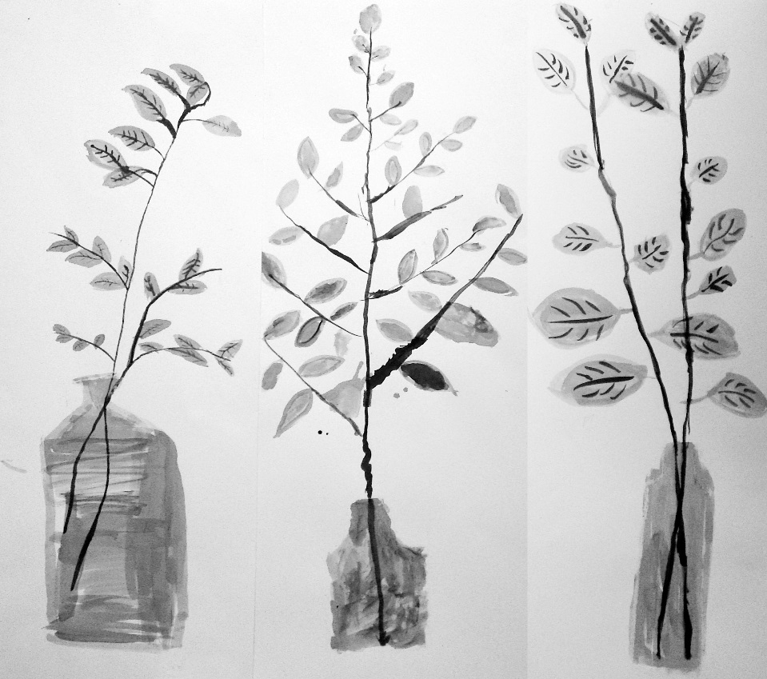
At St Mary’s Church, Surlingham
Saturday 07 December 10.00 – 4.00 pm
Sunday 08 December 10.00 – 2.00 pm
On the theme of ‘Colour’
Textiles, Painting, Collage, Drawing, Paper Mache
Celebrating the artwork of children from Alpington, Rockland St Mary & Surlingham Art Clubs.
Please support this unique event !
Artwork (L- R) Katherine Horrocks, Oliver Colgon, Ella Douglass.

The Art Club Winter Exhibition

