

Surlingham
Scarecrow Trail !

28-29 June 2014

Get Creative, Make a Scarecrow!
Support our Village School!
Win a Cash Prize!

The Friends of Surlingham School (FOSS) are running a Scarecrow Trail on the weekend of 28th / 29th June 2014. We hope that across the Surlingham community people will join in to make scarecrows to display outside their homes and around the village. Trail maps will be available for a small fee before and during the event which will guide visitors around the scarecrow trail and allow them to vote for their favourite scarecrow. A £25 pound prize will be awarded to the ‘Peoples Favourite’ scarecrow at the end of the weekend. All money raised will help to fund exciting projects for our children at Surlingham School.

Hints and tips for scarecrow building and an Entry Form can be found overleaf.

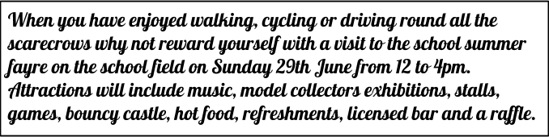

Hints, Tips and Rules!

- Scarecrows to be put in place on Friday 27th or early morning on Saturday 28th June please so that they are ready for viewing over the weekend.
- Make a scarecrow which showcases your interests, business or otherwise (advertising of local businesses is acceptable adjacent to scarecrows )
- Remember this is a family trail ­ please keep scarecrows appropriate for all ages!
- Ian Stiff has kindly donated straw for scarecrow making. Contact Victoria Wright if you need some.
- There is lots of scarecrow inspiration available on the internet ­ be as creative as you like!
- Please place your scarecrow adjacent to the road or public footpath areas so that people can easily see them when walking or driving round the village.
- We will provide you with an entry number, please display this clearly on or next to your scarecrow so that people know which number to vote for in the competition.

If you would like to make a scarecrow but live outside of the village please contact Victoria Wright on 01508 538132 and we will find a site for your scarecrow!

Entry Form

To enter a scarecrow in the trail please complete the short form below and return in a sealed envelope with the £2 entry fee to one of the following points:

- Victoria Wright at ‘The Nest’ Mill Road, Surlingham
- Surlingham School Office
- Surlingham Post Office and Shop

Please ensure all entries are in by Monday 16th June so that we can provide you with an entry number and put your scarecrow onto the trail map (scarecrows do not have to be completed on this date ­ as long as they are in place on 28th!).

Name:.................................................................................................................................

Address:............................................................................................................................

…………………………………………………………………………………………………………

…………………………………………………………………………………………………………

……………………………………………………Telephone……………………………………..

