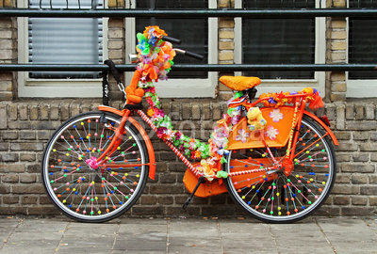
Best Dressed Bicycle Competition

At Surlingham Fayre

Saturday 5th September
1-4 at the school field
Free entry
Under 11 and 11 to Adults categories

