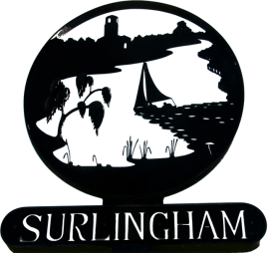

SURLINGHAM PARISH COUNCIL
AGENDA
Members
You are summoned to attend the meeting of Surlingham Parish Council to be held on Tuesday 19 December 2017 at the Parish Hall at 7.30pm.
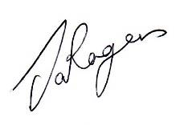Janet Rogers Parish Clerk
Tel: 01603 665341
- Apologies and approval of absences
- Declarations of Interest and requests for dispensation
- To approve as accurate the minutes of the meeting on 21 November 2017
- Matters arising from the previous minutes
- Progress reports for information: Councillors/Clerk
- To receive reports from the County and District Councillor
- Public Question Time (15 minutes)
- Planning application - 2017/2696
Applicant: Mr & Mrs S Ferrey
Location: Alderfen Common Road Surlingham Norfolk NR14 7AW
Proposal: Proposed Loft Conversion
- WW1 Commemoration – Councillors Dimmock/Reeve and Hiscocks
- Orchard – Councillor Scowen
- Correspondence – NCC Transport Subsidiary and Budget
- Finance
a) To authorise payments/cheques
- To note items for inclusion on the next council agenda
- To confirm the date of the next meeting 16 January 2018

Festive refreshments will be available from 7:00 p.m. and following the meeting.

