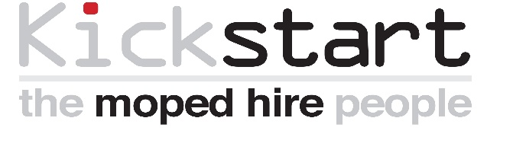
8 Royson Way, Dereham, Norfolk, NR19 1WD

tel: 01362 699923 fax: 01362 692789
web: www.kickstartmopeds.org.uk
Charity number: 1099931
_______________________________________________________________________________________________

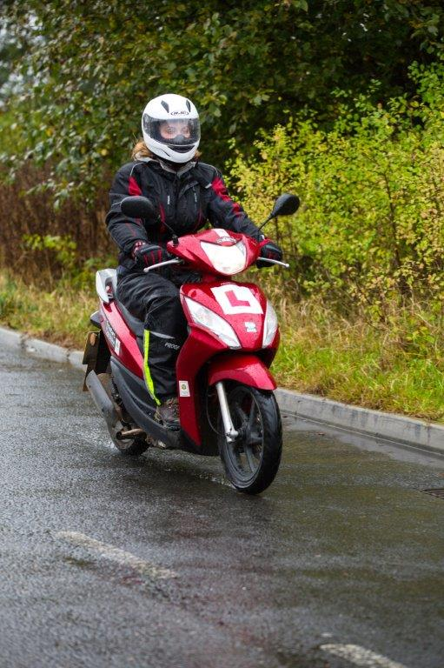
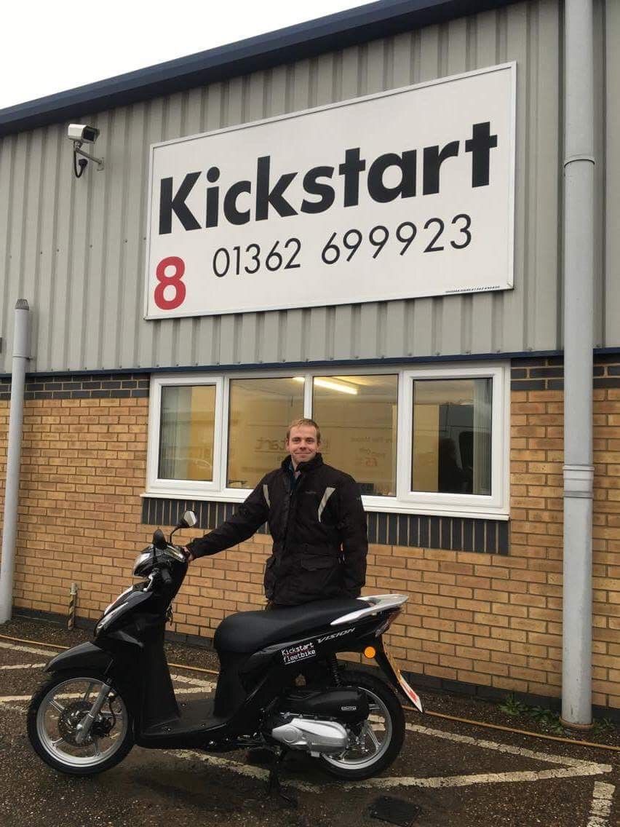

INTRODUCTION TO KICKSTART
& POTENTIAL FUNDING OPPORTUNITIES

Company Registration No: 4873541 - Registered Charity No: 1099931 - Registered Office: 8 Royson Way, Hurn Road, Dereham NR19 1WD - VAT Registration No: 787 0465 93, Authorised and regulated by the Financial Conduct Authority (710352). Current Kickstart partners/funders include: European Social Fund and the Big Lottery Fund, Jobcentre Plus, Norfolk County Council, North Norfolk District Council, South Norfolk Council, Seetec.

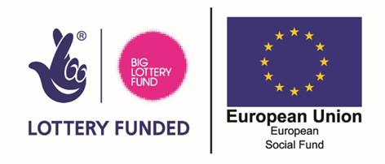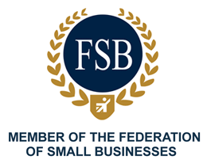


8 Royson Way, Dereham, Norfolk, NR19 1WD

tel: 01362 699923 fax: 01362 692789
web: www.kickstartmopeds.org.uk
Charity number: 1099931
INTRODUCTION –
The aim of this document is to give the reader an overview of the funding opportunities Kickstart Norfolk can potentially provide service users.
Our charity understands that a clients’ needs are best met by having access to a strong and diverse network of experts, and over the years we have forged excellent working relationships with many organisations, foundations and trusts. We are pleased to state that new working relationships continue to be forged and existing ones are going from strength to strength and this is enabling individuals to move forward with their lives and many are utilising the service and funding we are able to offer to release their potential.

As a charity, Kickstart Norfolk continues to research and apply for funding to ensure the cost of our moped schemes is kept to a minimum and our Board meet on a quarterly basis to review this. Unfortunately, funding is not always available and therefore, it can be left to individuals to self-fund the moped scheme unless an organisation, foundation, or trust will support them. Provided in this document are the details of potential funding opportunities the Kickstart Charity currently has available to service users; some of this funding has been secured via recent contracts, other funding is in place via an agreement with Jobcentre Plus. The individual rider must meet certain criteria and all funding is subject to change.
This document also provides details and a breakdown of all the costs. The Kickstart Charity will work with riders to ensure where possible a payment plan is put in place to keep the initial costs to a minimum.



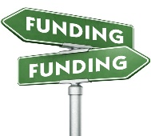
FUNDING OPPORTUNITIES –

On receipt of a Kickstart Application all potential funding streams will be researched to ensure we can provide the cheapest financial option to the individual. Provided below, are details of current potential funding, these include, The Kickstart Apprenticeship Fund, Building Better Opportunities (BBO) Fund and the Get Britain Working Fund.
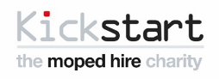


The Kickstart Charity Apprenticeship Fund -
The Kickstart Charity Apprenticeship Fund is available to any individual taking part in an Apprenticeship Scheme and there are no age restrictions. Therefore, if you, your staff or the individual themselves identify and secure an Apprenticeship, the Kickstart Charity can potentially provide the individual with funding for the following:
- Compulsory Bike Training (CBT) – required by law to ensure the individual is safe to ride the moped unsupervised. The CBT is delivered by one of our partners and will be confirmed with both the client and referring member of staff prior to any training taking place.

- Issue of safety equipment and clothing – Once the CBT has been passed and the Apprenticeship start date has been confirmed, the individual will be issued with the following:

- Motorcycle Helmet
- Motorcycle Armoured Jacket
- Waterpoof Trousers
- Pair of Motorcycle Gloves
- High Visibility Vest

- Issue of a 50cc moped – the Kickstart dedicated driver will deliver the moped to the individual at either their residential address or place of training. Prior to issuing the moped the driver will take the individual through a detailed handover looking at the following:

- Moped controls and safety features
- Daily & weekly checks that the individual is required to carryout
- Emergency numbers for AA breakdown
- Actions to be taken in the event of an accident, breakdown or individual wanting to return the moped
- Each moped also comes with a lock and chain for security

- Weekly Hire of the 50cc moped is subsidised for a period of up to 52 weeks. This requires the individual to make moped hire payments of £25 per week instead of the normal hire rate of £29.
- Saving: The Apprenticeship Fund also provides the individual with the CBT & Clothing free of charge giving them an additional saving of £250.
- All moped hire payments are made by direct debit which will be set up by the Kickstart Charity

To access the Kickstart Charity Apprenticeship Fund please complete and return the application form and relevant supporting forms (if applicable). Please Note: The individual will be required to hold a minimum of a Provisional Motorcycle Licence to obtain this funding, therefore, should the individual not hold a licence an application to obtain a Provisional Licence will need to be made.

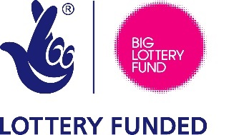
Building Better Opportunities Fund (BBO) –

The BBO Fund is potentially available to anyone living in the Greater Cambridgeshire & Greater Peterborough areas (GCGP) who are economically inactive or unemployed. The funding is designed to assist individuals to move forwards towards employment, so this means engaging in any form of employment, education, training, work trial, work experience or traineeship. The BBO funding is applied for by completing a Kickstart Application Form and once received, our team will assess the individual against the funding criteria. If successful, the BBO funding will provide the following:
- Funding for the individual to obtain a Provisional Motorcycle Licence (if required).
- Compulsory Bike Training (CBT) – required by law to ensure the individual is safe to ride the moped unsupervised. The CBT is delivered by one of our partners and will be confirmed with both the client and referring member of staff prior to any training taking place.
- Issue of safety equipment and clothing – Once the CBT has been passed the individual will be issued with the following:

- Motorcycle Helmet
- Motorcycle Armoured Jacket
- Waterproof Trousers
- Pair of Motorcycle Gloves
- High Visibility Vest
- Each moped comes with a lock and chain for security

- Issue of a 50cc moped – this involves our dedicated driver delivering the moped to the individual at either their residential address or place of employment, education or training and then a detailed handover will take place looking at the following:

- Moped controls and safety features
- Daily & weekly checks that the individual is required to carryout
- Emergency numbers for AA breakdown
- Actions to be taken in the event of an accident, breakdown or individual wanting to return the moped

- Free Weekly Hire of moped for a period of 12 weeks. At the end of the 12-week period the moped will be collected by the Kickstart Charity unless the individual states they are happy to self-fund the weekly hire cost of: £29
- All moped hire payments are made by direct debit which will be set up by the Kickstart Charity

Please Note: As the individual is funded for a 12-week period should they attend, for example, a 4-week training course, the moped will be collected at the end of the 4-week period and the individual can then access the scheme for a further 8 weeks. This means that the 12 weeks can be staggered, allowing the individual more flexibility with the funding.
The rider will be required to hold a minimum of a Provisional Motorcycle Licence to obtain this funding, therefore, should the individual not hold a licence an application to obtain a Provisional Licence will need to be made.


Get Britain Working Fund (GBW) –

It may be that an individual is best suited to take part in a Work Trial, Work Experience or Traineeship before they move forward towards securing employment. These types of provision may require the individual to travel to various locations or work unsociable hours when public transport is severely limited or unavailable.
The Get Britain Working Fund (BBO) is only available to individuals who are unemployed and working with a Jobcentre Plus Advisor to move towards employment. The fund enables the Kickstart Charity to provide access to our Moped Scheme to individuals who are attending a Work Trial, Work Experience or Traineeship, all of which can potentially lead to employment being secured. The Get Britain Working Fund can only be accessed via a referral from a Jobcentre Plus Advisor and will provide an individual with the following:
      - Compulsory Bike Training (CBT) – required by law to ensure the individual is safe to ride the moped unsupervised. The CBT is delivered by one of our partners and will be confirmed with both the client and referring member of staff prior to any training taking place.
      - Issue of safety equipment and clothing – once the CBT has been passed the individual will be issued with the following:

- Motorcycle Helmet
- Motorcycle Armoured Jacket
- Waterproof Trousers
- Pair of Motorcycle Gloves
- High Visibility Vest
- Each moped comes with a lock and chain for security

      - Issue of a 50cc moped – this involves our driver delivering the moped to the individual at either their residential address or place of training and then a detailed handover will take place looking at the following:

- Moped controls and safety features
- Daily & weekly checks that the individual is required to carryout
- Emergency numbers for AA breakdown
- Actions to be taken in the event of an accident, breakdown or individual wanting to return the moped

      - Free Weekly Hire of moped for a period of 12 weeks. At the end of the 12-week period the moped will be collected by the Kickstart Charity unless the individual states they are happy to self-fund the weekly hire cost of: £29
      - All moped hire payments are made by direct debit which will be set up by the Kickstart Charity

Please Note: An individual accessing the Get Britain Working Fund will be required to hold a minimum of a Provisional Motorcycle Licence therefore, if the individual is not in possession of this, an application to obtain a Provisional Licence will need to be made.
As the rider is funded for a 12-week period should they attend for example a 4-week training course, the moped will be collected at the end of the 4-week period and the individual can then access the scheme for a further 8 weeks. This means that the 12 weeks can be staggered, allowing the individual more flexibility with the funding. As a reminder, the Get Britain Working Fund can only be accessed via an application from Jobcentre Plus.




The Kickstart Norfolk, Rural Scheme –

With public transport facing more cuts, it is common knowledge that the largest barrier an unemployed individual residing in rural communities has is the lack of transport and it is often the first question an employer will ask. If an individual does not have transport the area in which they will search for employment is severely restricted and therefore, they rely on local employment opportunities that are often not available. Kickstart Norfolk have recognised this and to ensure service users have the best opportunity of moving forward to employment, the charity has secured funding that could provide an individual with transport for a period of up to 6 months for them to look for employment, training or education provisions. It may be the case that an individual’s first step to employment is to engage in community activities and therefore, the Rural Scheme can provide transport to be used for this.
The Kickstart Norfolk, Rural Scheme is only available to individuals residing across Norfolk and certain Suffolk areas who are unemployed and working with a Jobcentre Plus Advisor to move towards employment. The Rural Scheme will provide the individual with the following:
a. Issue of a 50cc Moped – The Rural Scheme will provide the moped at a discounted price of £17.

b. Issue of 110cc Scooter – The Rural Scheme will provide the scooter at a discounted price of £25.

By providing transport at a discounted price the Kickstart Norfolk, Rural Scheme is accessible to those on benefits. Unfortunately, at present there is no funding available to provide the individual with Compulsory Bike Training (CBT) or to issue them with Safety Clothing and Equipment. Therefore, it may be down to the individual to self-finance this or funding can be provided by an organisation, trust or foundation. When the individual is in a position to receive their transport, our dedicated driver will deliver the moped/scooter to the individual at either their residential address or place of training and then a detailed handover will take place.

Prior to joining the Rural Scheme, the individual will agree to both an Individual Action Plan and Communication Plan that will require them to speak to Kickstart’s Communication Officer on a weekly basis. The aim of the Communication Plan is to ensure that the Individual Action Plan is being adhered to and any issues identified are dealt with. Kickstart’s Communication Officer will communicate via email with Jobcentre Advisors to ensure they are kept informed of progress and any issues that arise. In line with Data Protection, prior to joining the Rural Scheme, the individual will sign a document giving their consent for their information to be shared.

On completion of the 6-month funded period the moped will be collected by the Kickstart Charity unless the individual states they are happy to self-fund the full weekly hire cost. Prior to joining a new scheme, a detailed budget plan will be completed.

All moped hire payments are made by direct debit which will be set up by the Kickstart Charity

Please Note: An individual accessing the Kickstart Rural Fund will be required to hold a minimum of a Provisional Motorcycle Licence therefore, if the individual is not in possession of this, an application to obtain a Provisional Licence will need to be made. As a reminder, the Kickstart Rural Fund can only be accessed via an application from Jobcentre Plus.

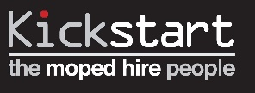



Other Funding
If an individual does not qualify for any of the funding already mentioned, the Kickstart team will automatically check other potential funding streams that may be available to help them attend the Compulsory Bike Training (CBT), be issued with the relevant safety clothing & equipment or to pay for the cost of a Provisional Licence. This funding is kindly provided by South Norfolk and Norfolk County Council but the individual must meet certain criteria to access this. Once the level of funding has been confirmed by our team we will inform both the applicant and the referring member of staff.
Please Note: sometimes potential applicants may not be eligible for any funding, therefore, could you please take the time to make them aware of this at an early stage to prevent any negative issues arising further down the application process.

 | Norfolk County Council kindly provide funding for up to 20 individuals residing in the County of Norfolk to take part in the Apprenticeship Scheme. Please note; this funding is subject to change and can be used for alternative reasons on agreeance with the Kickstart Board.
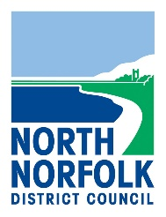 | North Norfolk Council kindly provide funding that enables individuals residing in the North Norfolk area to purchase their provisional driving licence or part-fund the purchase of safety equipment & clothing. Alternatively, this fund can be used to subsidise the moped hire fee. Please note; funding is limited to £50 per person.
 | South Norfolk Council kindly provide funding that enables 57 individuals residing in the South Norfolk area to purchase their provisional driving licence or part-fund the purchase of safety equipment & clothing. Alternatively, this fund can be used to subsidise the moped hire fee. Please note; funding is limited to £50 per person.

The Kickstart Charity Moped Scheme & Costs
As previously mentioned, funding is not always available for everyone and therefore, it may be down to the individual/organisation/trust to pay for the Moped Scheme. Provided below is a breakdown of costs.
Item | Discounted Cost
Compulsory Bike Training (CBT) |     Motorider CBT = Reduced from £125 to £90  Camrider Peterborough & Cambridge = £125  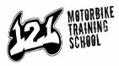  1-2-1 Motorbike Training School = £125
Moped Hire | 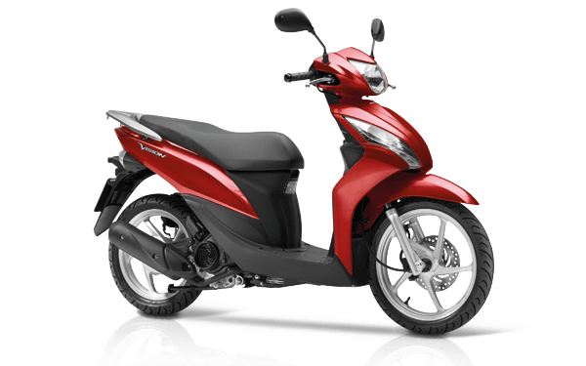  50cc = £29 per week – Please Note: Hire costs are reviewed quarterly and are therefore, subject to change.  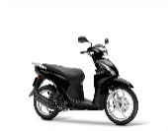  110cc = £39 per week - Please Note: Hire costs are reviewed quarterly and are therefore, subject to change.
Motorcycle Helmet | 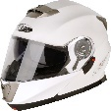  Reduced from £47 to £40
Armoured Motorcycle Jacket | 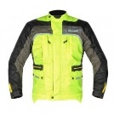  Reduced from £80 to £60
Motorcycle Gloves |   Reduced from £26 to £18
Waterproof Trousers | 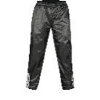  Reduced from £26 to £18
High Visibility Vest | 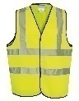  Reduced from £10 to £6

Please Note: the rider is not required to purchase any clothing, equipment or the CBT from the Kickstart Charity. However, no moped will be issued without the rider producing a copy of his/her CBT pass certificate along with the relevant clothing and safety equipment that must meet the required safety standards. This is in line with the Official Driver & Vehicle Standards Agency (DVSA).

Payment –
The Kickstart Charity currently works with several organisations which will fund an individual onto the Moped Scheme and they do this by setting up a payment agreement with the charity. If you would like to explore the possibility of funding an individual or individuals, please call our office to discuss this.
Frequently asked questions: clients and advisors will have many questions that will require answering. Provided below are the most common questions asked:
Question: Are there any age restrictions?
Answer: No, anyone aged 16 and above can apply for a Kickstart moped. If you are under the age of 18 you will need permission from a parent or guardian who will sign the issue document when you are issued with your moped.
Question: Do I need a licence?
Answer: Yes, you will need at least a UK/EU provisional licence to access the moped scheme.
Question: How much will it cost?
Answer: The hire fees varies depending on what the moped is being used for and regional funding variations, please refer to www.kickstartmopeds.co.uk or ring 01362 699923 for up-to-date costs.
Question: How long can I use the moped or scooter for?
Answer: There is a minimum period of 1 week but no maximum hire period, providing it is cost effective for us to do so you can use the vehicle for as short or long a period as you want, subject to our terms and conditions being met.
Question: How do I pay you for the hire of the moped?
Answer: Everyone using a moped or scooter is required to set up a direct debit via GoCardless and a member of our team will talk you through this. The hire fee is taken from your bank account on a date best suited to you. However, if you are paid weekly we would expect the direct debit to be paid weekly, and, if you are paid monthly we would expect the direct debit to be taken on a monthly basis.
Question: What happens if I fail to make payment?
Answer: If you are unable to make a payment we kindly request that you call the Kickstart office as soon as possible so that a payment plan can be set up. This will ensure the amount of hire fee does not build up to a point where it becomes unmanageable. As a charity, we rely on our service users paying their hire fees on time as this enables Kickstart to continue offering a transport service to its beneficiaries. We understand that there may be times when finances are tight and, therefore, we ask you to call the Kickstart team so that we can work with you to ensure you remain on the moped scheme.
Question: What happens if I ignore payments and my debt builds up?
Answer: Unfortunately, we sometimes have service users who fail to make the agreed hire fee payments and this causes a considerable hire fee debt to build up. Kickstart will attempt to communicate with the debtor to arrange a payment plan to ensure the money owed is paid and they remain on the moped. However, should this correspondence be ignored, the charity will have no choice but to take back the moped and retrieve the money owed by using a debt collector.
Question: So, what do I do next?
Answer: To start the wheels in motion we will need a completed application from you. You can get an application pack by:
- Completing an application form on our website www.kickstartmopeds.co.uk
- Completing an application form with your advisor/staff member.
- Calling Kickstart on telephone: 01362 699923 and we will complete the application form with you. Alternatively, we can email or post an application to you.

The Kickstart Charity – Application Process Chart

Summary:
Kickstart provides an affordable, alternative transport option for service users to travel to and from their place of employment, training or education. If you believe we can assist you, your staff and/or service user please send a completed application form to us. Should you require any further information please do not hesitate to call me on tel: 01362 699923 or alternatively on my mobile: 07387 268632.
If you would like a member of the Kickstart team to deliver a Moped Scheme presentation to your staff or clients please let me know and I will arrange a time to do this. Promotional Kickstart leaflets are now available for you to order free of charge, by calling the Kickstart office on: 01362 699923.

Kind regards,

Matthew Page

Matthew Page
Partnership Manager
Kickstart Norfolk
Tel: 01362 699923
Mob: 07387 268632

