



PCC News
July 2019
Welcome to the latest news update from Norfolk's Police and Crime Commissioner (PCC) Lorne Green.
For more information on the role, responsibilities and work of the PCC, please visit www.norfolk-pcc.gov.uk.


Praise for team working to keep young people out of criminal justice system
The PCC has praised the county's Youth Offending Team (YOT) for its work tackling youth crime and supporting vulnerable children and young people.
Find out more>>

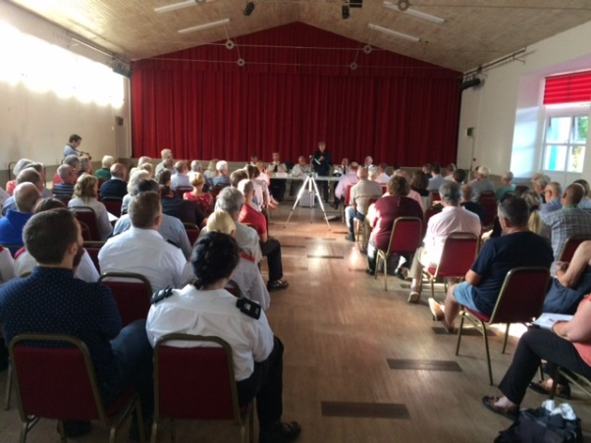
Fakenham hosts first police and fire Q&A event
More than 80 members of the public attended the county's first joint police and fire service question and answer session in Fakenham hosted by PCC Lorne Green.
Read more here>>

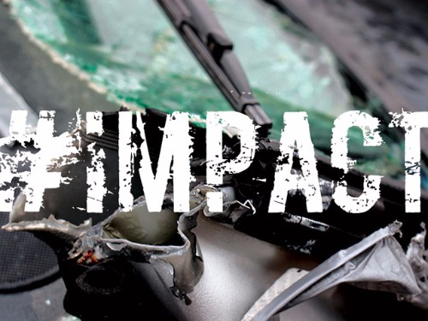
#Impact young driver campaign rounds off academic year with city demo
The team behind a road safety campaign targeted at college and sixth form students rounded off another successful year with a demonstration in Norwich city centre.
More information>>


OPCCN staff become Domestic Abuse Champions
Two colleagues at the Office of the Police and Crime Commissioner for Norfolk have become Domestic Abuse Champions in a bid to highlight the issue and provide vital support where needed.
Find out more>>

Copyright © 2019 Office of the Police and Crime and Commissioner for Norfolk, All rights reserved.
Our mailing address is:
Office of the Police and Crime and Commissioner for Norfolk
Building 8, Falconers Chase
Wymondham, Norfolk NR18 0WW
United Kingdom
Add us to your address book

