Some Words and Thoughts for the 4th Sunday of Easter.


Acts 2:42-47
⁴²They devoted themselves to the apostles’ teaching and fellowship, to the breaking of bread and the prayers. ⁴³Awe came upon everyone, because many wonders and signs were being done by the apostles. ⁴⁴All who believed were together and had all things in common; ⁴⁵they would sell their possessions and goods and distribute the proceeds to all, as any had need. ⁴⁶Day by day, as they spent much time together in the temple, they broke bread at home and ate their food with glad and generous hearts, ⁴⁷praising God and having the goodwill of all the people. And day by day the Lord added to their number those who were being saved.

Today’s reading from Acts is a description of the life of the Early Church. In some ways it reminds me of the life of the Church we have returned to today. A church without the focus of a central building, instead constructed around a shared life of eating together, praying together, caring for one another and praising God. Although many are isolated within the walls of their homes this simple focus of life has become central again. In the days ahead, the government will carefully consider how to relax some of the restrictions which have been imposed to minimize the spread of this awful disease and in time to come, we will have to consider how to be a gathered community of believers once more. As we look to a different future, what difference might this make to our life of faith? Perhaps the challenge of this time can also become an opportunity. We might prepare for this by beginning a big conversation about what matters most and how we might embrace, embody and enact that within our Christian life .

A starting point for our conversation might be the final verse of our Gospel reading for the day: Jesus said “I came that they may have life, and have it abundantly.”
What does abundant life mean for you and how can we share that both now and in the future?

John 10:1-10
10“Very truly, I tell you, anyone who does not enter the sheepfold by the gate but climbs in by another way is a thief and a bandit. ²The one who enters by the gate is the shepherd of the sheep. ³The gatekeeper opens the gate for him, and the sheep hear his voice. He calls his own sheep by name and leads them out. ⁴When he has brought out all his own, he goes ahead of them, and the sheep follow him because they know his voice. ⁵They will not follow a stranger, but they will run from him because they do not know the voice of strangers.” ⁶Jesus used this figure of speech with them, but they did not understand what he was saying to them. ⁷So again Jesus said to them, “Very truly, I tell you, I am the gate for the sheep. ⁸All who came before me are thieves and bandits; but the sheep did not listen to them. ⁹I am the gate. Whoever enters by me will be saved, and will come in and go out and find pasture. ¹⁰The thief comes only to steal and kill and destroy. I came that they may have life, and have it abundantly.

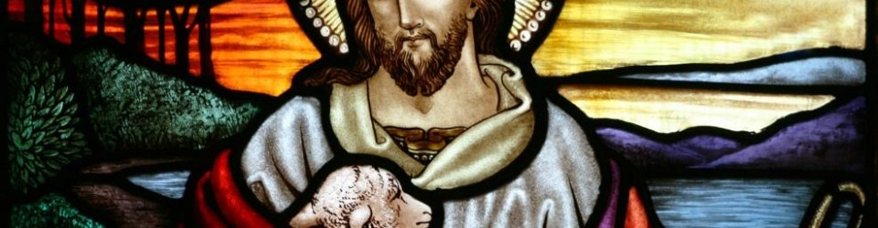

In joy and hope let us pray to the Father.
That our risen Saviour may fill us with the joy of his
glorious and life-giving resurrection …
we pray to the Father.
Hear our prayer.
That isolated and persecuted churches
may find fresh strength in the good news of Easter …
we pray to the Father.
Hear our prayer.
That God may grant us humility
to be subject to one another in Christian love …
we pray to the Father.
Hear our prayer.
That he may provide for those who lack food, work or shelter …
we pray to the Father.
Hear our prayer.
That by his power war, famine and disease may cease through all the world …
we pray to the Father.
Hear our prayer.

That he may reveal the light of his presence to the sick,
the weak and the dying,
to comfort and strengthen them …
we pray to the Father.
Hear our prayer.
That, according to his promises,
all who have died in the faith of the resurrection
may be raised on the last day …
we pray to the Father.
Hear our prayer.
That he may send the fire of the Holy Spirit upon his people,
so that we may bear faithful witness to his resurrection,
we pray to the Father.
Hear our prayer.
Heavenly Father,
you have delivered us from the power of darkness
and brought us into the kingdom of your Son:
grant that, as his death has recalled us to life,
so his continual presence in us may raise us to eternal joy;
through Christ our Lord.
Amen.

