Rockland Benefice in the Bramerton Group
St. Mary’s Surlingham

Morning Prayer
23rd August 2020 at 10am

Eleventh Sunday after Trinity

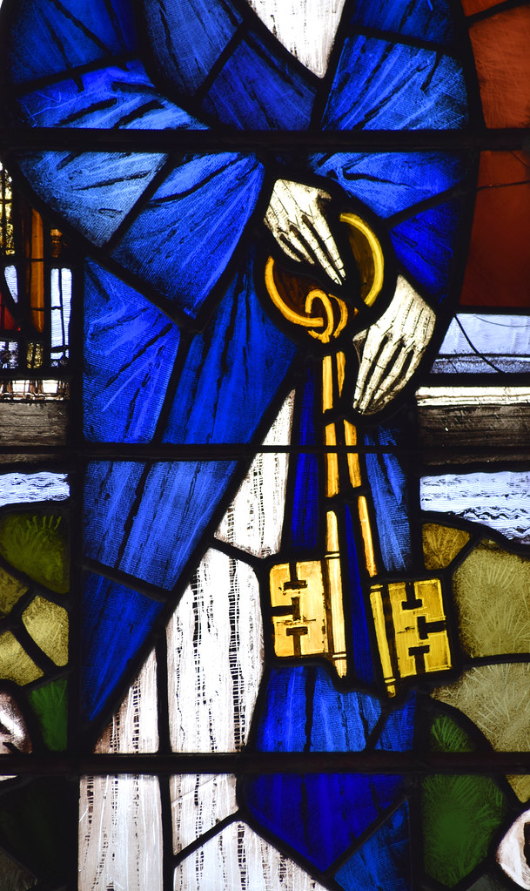

Welcome Back

Please observe social distancing guidelines and avoid singing.

Words of Welcome

Grace, mercy and peace

from God our Father

and the Lord Jesus Christ

be with you

All and also with you.

This is the day that the Lord has made.

All Let us rejoice and be glad in it.

We have come together in the name of Christ

to offer our praise and thanksgiving,

to hear and receive God’s holy word,

to pray for the needs of the world,

and to seek the forgiveness of our sins,

that by the power of the Holy Spirit

we may give ourselves to the service of God.
Hymn
- Take my life, and let it be
Consecrated, Lord, to Thee;
Take my moments and my days,
Let them flow in ceaseless praise,
Let them flow in ceaseless praise.

- Take my hands, and let them move
At the impulse of Thy love;
Take my feet and let them be
Swift and beautiful for Thee,
Swift and beautiful for Thee.

- Take my voice, and let me sing
Always, only, for my King;
Take my lips, and let them be
Filled with messages from Thee,
Filled with messages from Thee.
- Take my silver and my gold;
Not a mite would I withhold;
Take my intellect, and use
Every power as Thou shalt choose,
Every power as Thou shalt choose.

- Take my will, and make it Thine;
It shall be no longer mine.
Take my heart; it is Thine own;
It shall be Thy royal throne,
It shall be Thy royal throne.

- Take my love; my Lord, I pour
At Thy feet its treasure-store.
Take myself, and I will be
Ever, only, all for Thee,
Ever, only, all for Thee.
Canticle: Benedicite
1Bless the Lord all you works of the Lord:
sing his praise and exalt him for ever.
2Bless the Lord you heavens:
sing his praise and exalt him for ever.
3Bless the Lord you angels of the Lord:
sing his praise and exalt him for ever.
4Bless the Lord all people on earth:
sing his praise and exalt him for ever.
5O people of God bless the Lord:
sing his praise and exalt him for ever.
6Bless the Lord you priests of the Lord:
sing his praise and exalt him for ever.
7Bless the Lord you servants of the Lord:
sing his praise and exalt him for ever.
8Bless the Lord all you of upright spirit:
bless the Lord you that are holy and humble in heart.
The Song of the Three 35-37, 60-65
The night has passed, and the day lies open before us;
let us pray with one heart and mind.
Silence is kept.

As we rejoice in the gift of this new day,
so may the light of your presence, O God,
set our hearts on fire with love for you;
now and for ever.
All Amen.

The Word of God

Psalm 138
1 I will give thanks to you, O Lord, with my whole heart; ♦
before the gods will I sing praise to you.
2 I will bow down towards your holy temple and praise your name, because of your love and faithfulness; ♦
for you have glorified your name
and your word above all things.
3 In the day that I called to you, you answered me; ♦
you put new strength in my soul.
4 All the kings of the earth shall praise you, O Lord, ♦
for they have heard the words of your mouth.
5 They shall sing of the ways of the Lord, ♦
that great is the glory of the Lord.
6 Though the Lord be high, he watches over the lowly; ♦
as for the proud, he regards them from afar.

7 Though I walk in the midst of trouble,
you will preserve me; ♦
you will stretch forth your hand against the fury of my enemies;
your right hand will save me.
8 The Lord shall make good his purpose for me; ♦
your loving-kindness, O Lord, endures for ever;
forsake not the work of your hands.

Glory to the Father and to the Son and to the Holy Spirit:
as it was in the beginning is now and ever shall be for ever,
Amen.

Bible Reading Matthew 16:13-20

¹³ Now when Jesus came into the district of Caesarea Philippi, he asked his disciples, 'Who do people say that the Son of Man is?'
¹⁴ And they said, 'Some say John the Baptist, but others Elijah, and still others Jeremiah or one of the prophets.' ¹⁵ He said to them,
'But who do you say that I am?' ¹⁶ Simon Peter answered,
'You are the Messiah, the Son of the living God.' ¹⁷ And Jesus answered him, 'Blessed are you, Simon son of Jonah!
For flesh and blood has not revealed this to you, but my Father in heaven. ¹⁸ And I tell you, you are Peter, and on this rock I will build my church, and the gates of Hades will not prevail against it.
¹⁹ I will give you the keys of the kingdom of heaven, and whatever you bind on earth will be bound in heaven, and whatever you loose on earth will be loosed in heaven.' ²⁰ Then he sternly ordered the disciples not to tell anyone that he was the Messiah.
Awake, O sleeper, and arise from the dead
All And Christ shall give you light.
You have died and your life is hid with Christ in God.
All Awake, O sleeper, and arise from the dead.
Set your minds on things that are above,
not on things that are on the earth.
All And Christ shall give you light.
When Christ our life appears you will appear with him in glory.
All Awake, O sleeper, and arise from the dead,
and Christ shall give you light.

Talk

Prayers

The Collect of the day is said
God of glory,
the end of our searching,
Help us to lay aside all that prevents us
from seeking your kingdom,
and to give all that we have
to gain the pearl beyond all price,
through our Lord and Saviour Jesus Christ.
All Amen.

Let us pray with confidence as our Saviour has taught us
All Our Father, who art in heaven,
hallowed be thy name;
thy kingdom come;
thy will be done;
on earth as it is in heaven.
Give us this day our daily bread.
And forgive us our trespasses,
as we forgive those who trespass against us.
And lead us not into temptation;
but deliver us from evil.
For thine is the kingdom,
the power and the glory,
for ever and ever.
Amen.

Hymn

1 Tell out, my soul, the greatness of the Lord!
Unnumbered blessings, give my spirit voice;
tender to me the promise of his word;
in God my Saviour shall my heart rejoice.

2 Tell out, my soul, the greatness of his name!
Make known his might, the deeds his arm has done;
his mercy sure, from age to age the same;
his holy name, the Lord, the mighty one.

3 Tell out, my soul, the greatness of his might!
Powers and dominions lay their glory by.
Proud hearts and stubborn wills are put to flight,
the hungry fed, the humble lifted high.

4 Tell out, my soul, the glories of his word!
Firm is his promise, and his mercy sure.
Tell out, my soul, the greatness of the Lord

To children’s children and for ever more.

The Conclusion
The Lord bless us, and preserve us from all evil,
and keep us in eternal life.
All Amen.
Let us bless the Lord.
All Thanks be to God.

_______________________________________________________

Rockland Benefice 2020
© The Archbishops' Council of the Church of England, 2000-2005
Official Common Worship apps, books and eBooks are available from Church House Publishing. The Bible readings (other than the psalms) are from The New Revised Standard Version Anglicized Edition, copyright 1989, 1995 Division of Christian Education of the National Council of the Churches of Christ in the United States of America. Used by permission. All rights reserved.
Tell out my soul © Timothy Dudley-Smith

