Rockland Benefice in the Bramerton Group
St. Andrew’s Claxton

Morning Prayer
30th August 2020 at 10am

Twelfth Sunday after Trinity

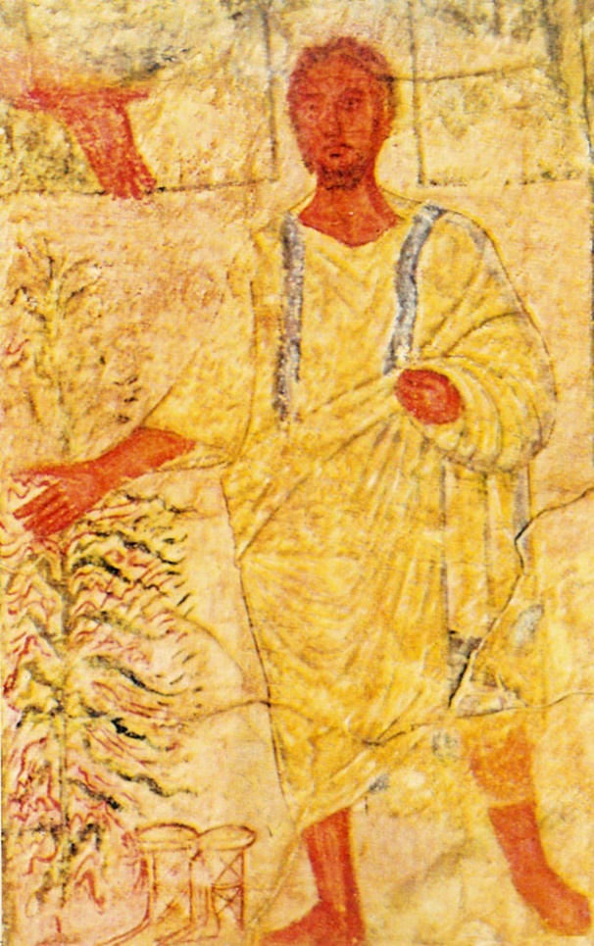

Welcome

Please observe social distancing guidelines.

Words of Welcome

Grace, mercy and peace

from God our Father

and the Lord Jesus Christ

be with you

All and also with you.

This is the day that the Lord has made.

All Let us rejoice and be glad in it.

We have come together in the name of Christ

to offer our praise and thanksgiving,

to hear and receive God’s holy word,

to pray for the needs of the world,

and to seek the forgiveness of our sins,

that by the power of the Holy Spirit

we may give ourselves to the service of God.
[Hymn or music]
Canticle: Benedicite
1Bless the Lord all you works of the Lord:
sing his praise and exalt him for ever.
2Bless the Lord you heavens:
sing his praise and exalt him for ever.
3Bless the Lord you angels of the Lord:
sing his praise and exalt him for ever.
4Bless the Lord all people on earth:
sing his praise and exalt him for ever.
5O people of God bless the Lord:
sing his praise and exalt him for ever.
6Bless the Lord you priests of the Lord:
sing his praise and exalt him for ever.
7Bless the Lord you servants of the Lord:
sing his praise and exalt him for ever.
8Bless the Lord all you of upright spirit:
bless the Lord you that are holy and humble in heart.
The Song of the Three 35-37, 60-65
The night has passed, and the day lies open before us;
let us pray with one heart and mind.
Silence is kept.

As we rejoice in the gift of this new day,
so may the light of your presence, O God,
set our hearts on fire with love for you;
now and for ever.
All Amen.

The Word of God

Psalm 26.1-8
1 Give judgement for me, O Lord,
for I have walked with integrity; ♦
I have trusted in the Lord and have not faltered.
2 Test me, O Lord, and try me; ♦
examine my heart and my mind.
3 For your love is before my eyes; ♦
I have walked in your truth.
4 I have not joined the company of the false, ♦
nor consorted with the deceitful.
5 I hate the gathering of evildoers ♦
and I will not sit down with the wicked.
6 I will wash my hands in innocence, O Lord, ♦
that I may go about your altar,
7 To make heard the voice of thanksgiving ♦
and tell of all your wonderful deeds.
8 Lord, I love the house of your habitation ♦
and the place where your glory abides.

Glory to the Father and to the Son and to the Holy Spirit:
as it was in the beginning is now and ever shall be for ever,
Amen.

Bible Reading Exodus 3.1-15
Moses was keeping the flock of his father-in-law Jethro, the priest of Midian; he led his flock beyond the wilderness, and came to Horeb, the mountain of God. ²There the angel of the Lord appeared to him in a flame of fire out of a bush; he looked, and the bush was blazing, yet it was not consumed. ³Then Moses said, “I must turn aside and look at this great sight, and see why the bush is not burned up.” ⁴When the Lord saw that he had turned aside to see, God called to him out of the bush, “Moses, Moses!” And he said, “Here I am.” ⁵Then he said, “Come no closer! Remove the sandals from your feet, for the place on which you are standing is holy ground.” ⁶He said further, “I am the God of your father, the God of Abraham, the God of Isaac, and the God of Jacob.” And Moses hid his face, for he was afraid to look at God.
⁷Then the Lord said, “I have observed the misery of my people who are in Egypt; I have heard their cry on account of their taskmasters. Indeed, I know their sufferings, ⁸and I have come down to deliver them from the Egyptians, and to bring them up out of that land to a good and broad land, a land flowing with milk and honey, to the country of the Canaanites, the Hittites, the Amorites, the Perizzites, the Hivites, and the Jebusites. ⁹The cry of the Israelites has now come to me; I have also seen how the Egyptians oppress them. ¹⁰So come, I will send you to Pharaoh to bring my people, the Israelites, out of Egypt.”
¹¹But Moses said to God, “Who am I that I should go to Pharaoh, and bring the Israelites out of Egypt?” ¹²He said, “I will be with you; and this shall be the sign for you that it is I who sent you: when you have brought the people out of Egypt, you shall worship God on this mountain.” ¹³But Moses said to God, “If I come to the Israelites and say to them, ‘The God of your ancestors has sent me to you,’ and they ask me, ‘What is his name?’ what shall I say to them?” ¹⁴God said to Moses, “I AM WHO I AM.” He said further, “Thus you shall say to the Israelites, ‘I AM has sent me to you.’“ ¹⁵God also said to Moses, “Thus you shall say to the Israelites, ‘The Lord, the God of your ancestors, the God of Abraham, the God of Isaac, and the God of Jacob, has sent me to you’: This is my name forever, and this my title for all generations.

Awake, O sleeper, and arise from the dead
All And Christ shall give you light.
You have died and your life is hid with Christ in God.
All Awake, O sleeper, and arise from the dead.
Set your minds on things that are above,
not on things that are on the earth.
All And Christ shall give you light.
When Christ our life appears you will appear with him in glory.
All Awake, O sleeper, and arise from the dead,
and Christ shall give you light.

Prayers

The Collect of the day is said
God of constant mercy,
who sent your Son to save us; remind us of your goodness, increase your grace within us, that our thankfulness may grow,
through Jesus Christ our Lord.
All Amen.

Let us pray with confidence as our Saviour has taught us
All Our Father, who art in heaven,
hallowed be thy name;
thy kingdom come;
thy will be done;
on earth as it is in heaven.
Give us this day our daily bread.
And forgive us our trespasses,
as we forgive those who trespass against us.
And lead us not into temptation;
but deliver us from evil.
For thine is the kingdom,
the power and the glory,
for ever and ever.
Amen.

[Hymn or music]

The Conclusion
The Lord bless us, and preserve us from all evil,
and keep us in eternal life.
All Amen.
Let us bless the Lord.
All Thanks be to God.

_______________________________________________________

Rockland Benefice 2020
© The Archbishops' Council of the Church of England, 2000-2005
Official Common Worship apps, books and eBooks are available from Church House Publishing. The Bible readings (other than the psalms) are from The New Revised Standard Version Anglicized Edition, copyright 1989, 1995 Division of Christian Education of the National Council of the Churches of Christ in the United States of America. Used by permission. All rights reserved.
Moses at the Burning Bush, c.250 AD, Fresco in Dura-Europa, from Art in the Christian Tradition,
a project of the Vanderbilt Divinity Library, Nashville, TN.

