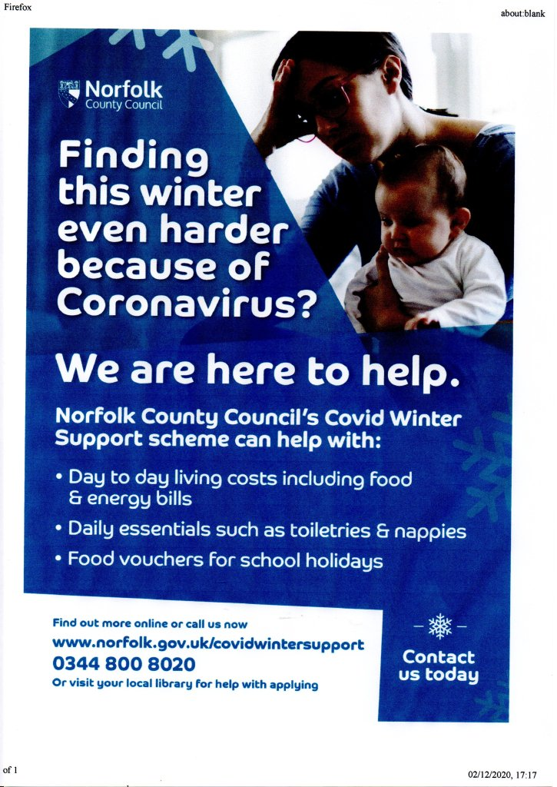
Anyone in Norfolk suffering financial hardship this winter could receive help and support thanks to a new scheme that launched Wednesday 2 December.
Norfolk County Council, alongside local councils across Norfolk, is aiming to support as many residents as possible this winter to access financial and other support if they are facing hardship.
The Norfolk Covid Winter Support Scheme is particularly aimed at families and will provide support for those suffering financial hardship over the winter months due to Covid-19. Support is available with food and utility bills.
Applications to the new support scheme can be made online, via the existing Norfolk Assistance Scheme pages at www.norfolk.gov.uk/NAS or applicants can call 0344 800 8020. From Wednesday 2 December, assistance in applying online will also be available through Norfolk Libraries.
In addition to this scheme we are working with food voucher company Edenred to provide support for all those eligible for free school meals, children in the early years who receive pupil premium and all the council’s care leavers during the Christmas holidays. We are encouraging eligible families to register and apply for free school meals through their school, so that they begin to receive support in time for the school holidays.
Whether it’s food or bills, our Winter Support scheme offers a lifeline to those worst hit by this pandemic and its effects. Encourage those who need help to apply and get the support they need.
The Covid Winter Support scheme can help with:
- Day to day living costs, including food and energy bills
- Daily essentials such as toiletries, sanitary products and nappies
- Food vouchers for the school holidays
As part of the wider package of support for families this winter, the council is also extending the Norfolk Assistance Scheme, which already provides support for food, fuel, clothes and other essential household items to Norfolk’s residents experiencing hardship.
More information is available online at www.norfolk.gov.uk/covidwintersupport or www.norfolk.gov.uk/NAS
Funding for winter support schemes has come from a range of sources:
- A £1m grant from Defra. £200k of this has been allocated to Norfolk Community Foundation and the remainder has been used to supplement the Norfolk Assistance Scheme (NAS)
- £500k of additional government Covid grant
- £2.7m of Covid Winter Grant, which will be used to fund the Edenred scheme and extend the reach of NAS
- £1.15m of the council’s core budgets – including funding for NAS
Covid Connectors
Working closely with our communities has been a key focus for every district across Norfolk during the Covid 19 pandemic. With the Tiers coming into place on Wednesday 2 December, Covid marshals and support officers will continue to be recruited and deployed across the county. Their aim is to advise, educate, and engage with businesses and members of the public around the restriction, working together to tackle the threats we all still face and bring us down into Tier 1. As well as providing support to the communities they work in, they also act as the eyes and the ears of the districts, reporting back improvements that could be made, concerns and repeat offenders.
While they all share similar role profiles (see examples below), each district is using their marshals, support officers or support advisors slightly differently. The funding for the roles has been provided by the central government Covid Outbreak Management Fund.
Broadland and South Norfolk have interviewed and made offers of six-month fixed-term contracts to 10 Covid Support Advisors who will start on Monday next week, following the attached role profile. They will be managed through two district team leaders, due to be interviewed shortly, who will provide daily briefing and tasking from their offices in Thorpe St Andrew and Long Stratton. It is important to note that these are support and advice roles rather than enforcement roles. Enforcement will be picked through their existing regulatory teams, however, as most Covid issues, things are moving at pace and there may be changes to this position at short notice. All Covid-related roles will liaise closely with district command policing and – on the ground – with beat managers.
Norwich have Covid 19 Support Officers, who during lockdown have been a core group of four to six patrolling the city each day between 10am and 4pm. The officers have been working with those businesses that are permitted to open to ensure that they are maintaining high levels of Covid protection and have been identifying businesses that may be trading when the legislation requires them to be closed. The team is managed by their Events Team and any issues that are identified by the support officers are relayed to the Environmental Health Enforcement Teams.
As the city reopens, they will be increasing the number of Covid19 Support Officers to pre-lockdown levels of up to 20 people on duty per day. To increase the impact of the officers, they will work in two shifts to cover the daytime business economy of 9am to 6pm. They will work to increase their interaction with the public and focussing on the key messages of hands: face: space. Street signage will be improved and there will also be the provision of information booths offering hand sanitiser and face coverings.
Don’t drink and drive
We are urging members of the public to consider the #IMPACT of drink or drug driving this year as we launch our Christmas campaign. Read more here > http://ow.ly/OEhU50CzoVB #PC460

Make a young person smile this Christmas
The Norfolk public and county council staff are being asked to bring some festive cheer to 16 and 17 year olds in care this Christmas.
It’s been a difficult year and young people have been hit especially hard by the pandemic. Teenagers living in supported accommodation may not have their families around them this Christmas and for many, a donation from you might be the only gift they get this year.
The Christmas Collection campaign for 16 and 17 year olds has been running now for several years but because of the pandemic this year it will be organised slightly differently. Instead of donating physical gifts, people are being asked to give digitally by sending e-gift vouchers. The deadline for donations is December 16.
Speaking about last year’s campaign, one of the accommodation providers said: “The young people have always been very appreciative of the donations you have given them at Christmas, we do our best to get the guys things they would like at Christmas time. However, a lot of young people do not see many of their extended family and some don't see their parents, so it is lovely to see them creating positive memories and having an enjoyable Christmas.
The gifts you have brought the young people gives them the knowledge that there is someone else who cares and is thinking about them. The hair dye was a particular hit with a group of girls we had one year! it's those little luxuries that they would not otherwise be able to afford.”

How to donate:
- Visit our Christmas collection wish website www.norfolk.gov.uk/christmascollection
- Select a suitable e-voucher retailer
- Purchase a gift voucher however small and email it to our elves at Christmascollection@norfolk.gov.uk
- Gift vouchers and some purchased gifts will be distributed to teenagers in need by our team of social workers by Christmas Eve
Name the Gritters
In November we put the call out for some fun creative names for our 7 new gritting vehicles. We know you've been waiting, itching to find out the results – letters have poured in from across the globe pleading with us to make the final decision public, and the phones have been ringing off the hook!
Well, we can announce that after much deliberation our judging panel have picked the top names for our 7 new gritters. Enter, our new Winter Warriors:
SNOWY – Magdalen Academy, Wiggenhall St Mary
TRUE GRIT – Harleston CE Primary Academy
GRITTER ME TIMBERS – Foulsham Primary
GRITTER MCGRITTY FACE – Recreation Road Infant School Norwich
LEW 'ICE' HAMILTON – Fred Nicholson School Dereham
GRINCH THE GRITTER – Scarning VC Primary School
ICEMELTER – Heacham Infant and Nursery
Thank you to all the pupils and teachers for submitting their excellent entries. The names will be proudly emblazoned on the gritter covering each school's area of Norfolk to be seen out and about.
#NorfolkWinter

Tree planting
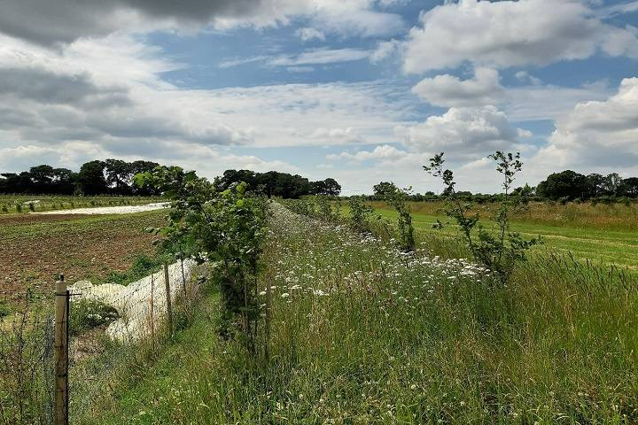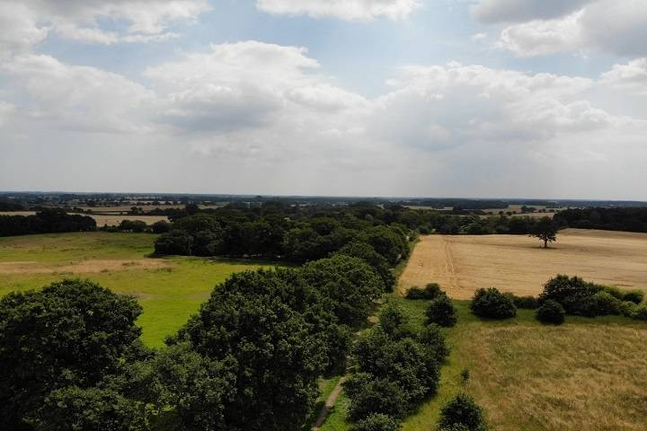
https://www.norfolk.gov.uk/what-we-do-and-how-we-work/campaigns/1-million-trees-for-norfolk
For the second year running Norfolk has come first among its peers in a national highways and transport survey.
Over the summer 3,300 people in Norfolk were asked for their views on topics such as road safety, highway maintenance, congestion and public transport as part of the National Highways and Transport (NHT) survey 2020.
The results are ranked against other participating councils from across the country to give a nationwide picture of how Norfolk is performing.
Out of the 29 county councils and larger unitary authorities in the peer group, Norfolk secured the top spot for overall satisfaction and saw the highest above average scores in both satisfaction with ‘traffic levels and congestion’ and ‘condition of highways’.
Successful bids for government funding has seen us secure £25.5m for this year, boosting our highways maintenance budget to £38.6 million for 2020-21. One of the biggest schemes made possible by that extra money was the resurfacing of a section of the busy A1066 near Thetford, which was completed just last week.”
For the first time this year there were new questions in the survey seeking opinions on changing travel habits and congestion charging. Responses showed that people 'strongly disagreed' with the statement that they could travel less by car than they currently do and 'strongly disagreed' that they could walk, cycle or use public transport more than they currently do. It is hoped that this score will improve as improvements to allow people a wider range of active travel options are made across Norfolk. The most popular answer to the question about congestion charging was to 'strongly oppose' such a scheme being introduced.
It is hoped the investment being made in installing more LED streetlights on Norfolk’s main roads will not only help reduce electricity consumption and contribute towards Norfolk’s journey to net zero, but also help improve customer satisfaction with streetlighting in future NHT surveys.
Norfolk Residents' Panel
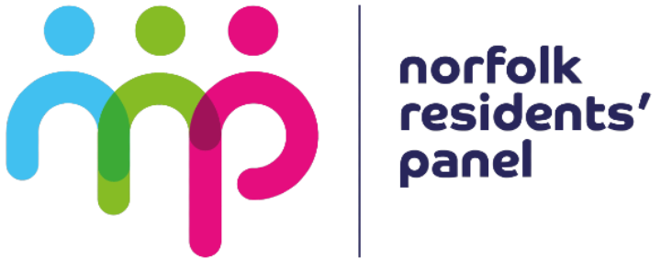
We want to listen to the people of Norfolk and for them to get involved when the Council makes decisions.
As the Council looks to the future, and the many challenges it faces, we want local residents to help us decide which direction to take and how we can all get Norfolk thriving.
We set up the Norfolk Residents' Panel to help us have these conversations.
How to sign up
You can sign up to the panel online and take our first survey about the COVID-19 pandemic and its impact on our area.
If you would like to become a member of the Norfolk Residents’ Panel, but would prefer a paper copy of the survey, or if you would like to receive a translated survey, email residentspanel@norfolk.gov.uk.
Sign up online
More about the Residents' Panel
The Norfolk Residents’ Panel is your chance to have your say on matters that affect Norfolk.
The purpose of the panel is to enable local people to share their views on how Norfolk County Council can best provide and improve its services to the county’s residents. It will also to help shape Norfolk’s future as the county faces up to the effects of the COVID-19 pandemic.
The panel is made up of an average of 2000 residents from across Norfolk. They are invited to participate in surveys, focus groups and online sessions throughout the year about a range of topics affecting Norfolk. They help Norfolk County Council make decisions and improve our services.
Members of the panel will be recruited to be broadly representative of the wider population of the area in terms of demographics and where they live in Norfolk. Panel members will be invited to be involved in engagement exercises and participate in surveys throughout the year, enabling us to:
Seek feedback on local services, particularly around how they may need to change in future, as we deal with the effects of the coronavirus pandemic
Help identify future needs and priorities
Give views on any new proposals
Be a voice on how we share information with residents
Why have I been asked to be a panel member?
Our recruitment to the panel is made up of two strands:
Organic recruitment - this is when someone asks to be a member of the panel independently, maybe after clicking a link on social media or hearing about the panel through the press
Targeted recruitment - this is when we contact people whose email address we got from leased email data. In the case of the Residents’ Panel, this was provided by a consumer database from a GDPR compliant data supplier, UK Datahouse. Consumer data is legitimately collected from websites, online forms and lifestyle surveys, where people have indicated they can be contacted for sales and marketing purposes via an opt-in method of sign up. Norfolk County Council is working with independent research group M.E.L Research to oversee this process.
Regardless of how you found out about the panel, if you choose to join you will get the same experience.
What will I need to do?
Panel members will be invited to take part in at least three online surveys a year and may also be invited to take part in further research. All participation is voluntary. We will keep you updated on the results of the research and tell you about you of more ways to get involved via a regular email newsletter.
How often will you contact me?
You will receive a regular newsletter via email, but we will keep correspondence with you to a minimum. These newsletters will feature results of surveys, regular updates on further engagement opportunities and a rundown of decisions made by Norfolk County Council.
What do I get for taking part?
As well as helping to shape Norfolk County Council services, those who complete a survey will be entered into an annual prize draw for the chance to win one of three £50 cash prizes. The more surveys you enter, the better your chances of winning!
If you are chosen to participate in further research there will be an additional cash incentive. The prize draw is paid for, administered and managed by M.E.L Research.
Who are M.E.L Research?
For the first two years of this project, Norfolk County Council have partnered with M.E.L Research, an independent social research company. Read their privacy policy to find out how they use the information you've provided, including your privacy rights and your right to withdraw your consent at any time.
Your privacy and data
We’ll keep the personal information you give us safely and will only use it for legitimate research purposes. All data stored through the surveys will comply with GDPR regulations and with the privacy policies set by Norfolk County Council.
Read our privacy notice.
If you have any queries about the Residents’ Panel, email residentspanel@norfolk.gov.uk.

- Scam Alert – Emails claiming to be from ‘DPD’
- Scam Alert – Emails claiming to be from ‘Royal Mail’
- Information Alert – Scamnesty 2020 – Lotteries & Prize Draw Scams
- News Alert –Avian Influenza (Bird Flu) - New Housing Measures
- Information Alert – Door to Door Sales
- Recall Alert – John Lewis is recalling a number of their Baby Sleeping Bags due to an issue with the popper which could pose a choking hazard
- Food Alert – Nestle recalls their chilled ‘Nescafe Shakissimo Espresso Latte’ due to contamination with residues of cleaning solution

