The Rockland Benefice
Morning Worship
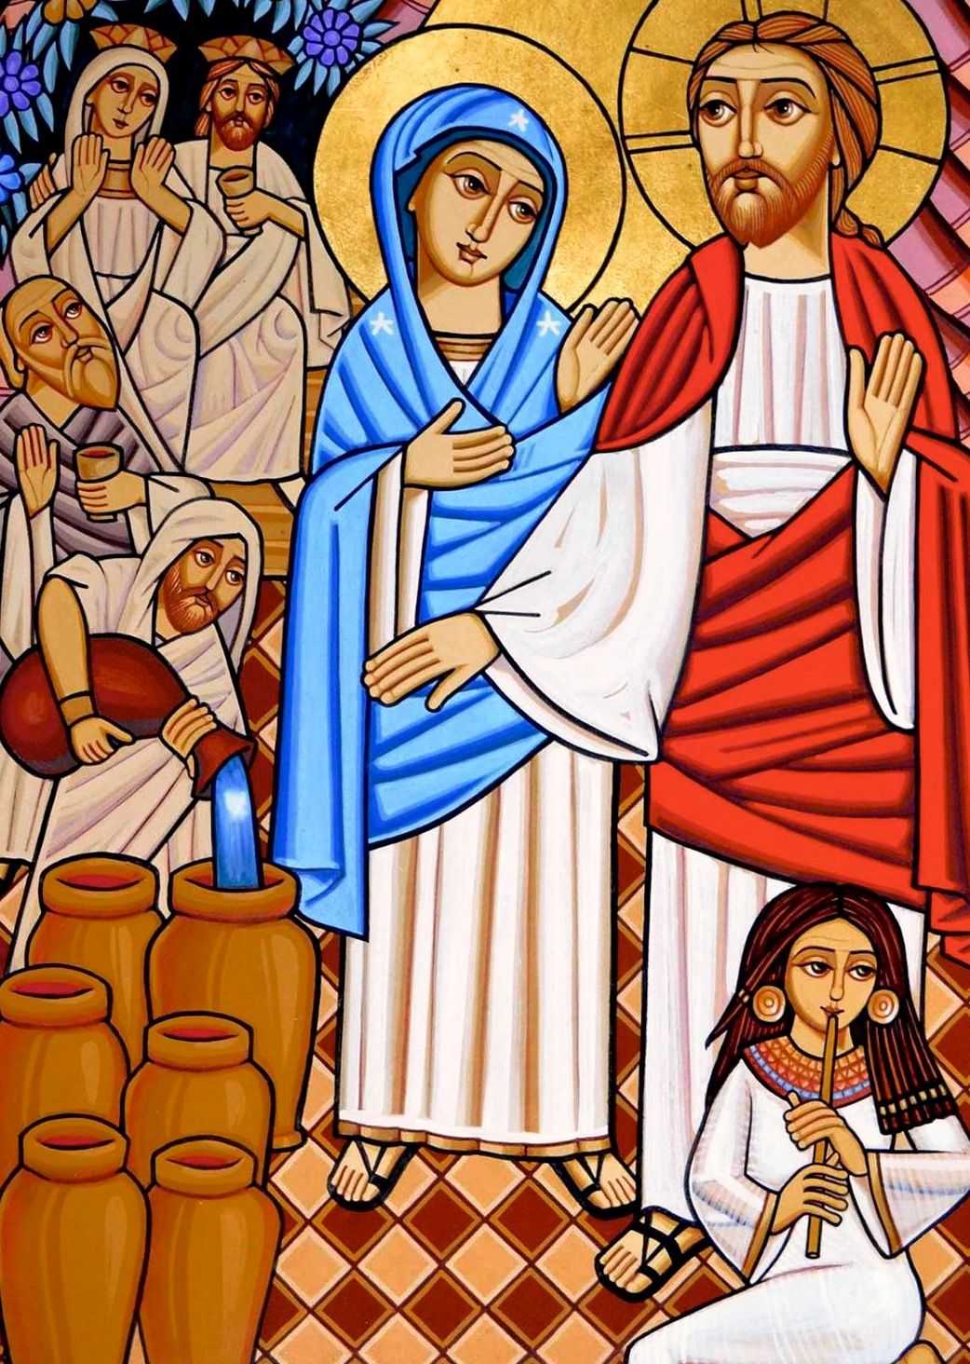
“…….you have kept the good wine until now.”
Sunday January 24th 2021

Welcome and Introduction

The God of heaven has made his home on earth.
Christ dwells among us and is one with us.
The highest of all creation lives among the least.
Christ journeys with the rejected
and welcomes the weary.
Come now all who thirst
and drink the water of life.
Come now all who hunger
and be filled with good things.
Come now all who seek
and be warmed by the fire of love.

The candles are lit
Come, Lord, come to us.
Enter our darkness with your light,
Fill our emptiness with your presence,
Come refresh, restore, renew us.
In our sadness, come as joy,
In our troubles, come as peace,
In our fearfulness, come as hope,
In our darkness, come as light,
In our frailty, come as strength,
In our loneliness come as love,
Come, refresh, restore, renew us.

Confession and Absolution:

God our Father,
long-suffering, full of grace and truth,
you create us from nothing and give us life.
You give your faithful people new life in the water of baptism.
You do not turn your face from us, nor cast us aside.
We confess that we have sinned
against you and against our neighbour.
We have wounded your love and marred your image in us.
Restore us for the sake of your Son,
and bring us to heavenly joy,
in Jesus Christ our Lord.
Amen.

May the God of love bring us back to himself,
forgive us our sins,
and assure us of his eternal love
in Jesus Christ our Lord.
Amen.

Jubilate everybody, serve the Lord in all your
ways, and come before his presence singing,
enter now his courts with praise.
For the Lord our God is gracious and his mercy’s
everlasting, Jubilate, jubilate, Jubilate Deo.
He’s our maker, we his creatures | we’re his sheep and
he’s our shepherd. Jubilate, jubilate, Jubilate Deo.
To the Father, Son and Spirit, now and evermore
give glory. Jubilate, jubilate, Jubilate Deo.

Psalm 128:1-2, 3, 4-5
Blessed are all who fear the Lord,
and walk in his ways!
By the labour of your hands you shall eat.
You will be blessed and prosper.
R. Blessed are those who fear the Lord.
Your wife like a fruitful vine
in the heart of your house;
Your children like shoots of the olive.
around your table.
R. Blessed are those who fear the Lord.
Indeed thus shall be blessed
the man who fears the Lord.
May the Lord bless you from Zion:
all the days of your life!
May you see your children’s children.
R. Blessed are those who fear the Lord.

Readings:
Revelation 19: 6-9
⁶Then I heard what seemed to be the voice of a great multitude, like the sound of many waters and like the sound of mighty thunderpeals, crying out, “Hallelujah! For the Lord our God the Almighty reigns. ⁷Let us rejoice and exult and give him the glory, for the marriage of the Lamb has come, and his bride has made herself ready; ⁸to her it has been granted to be clothed with fine linen, bright and pure”— for the fine linen is the righteous deeds of the saints. ⁹And the angel said to me, “Write this: Blessed are those who are invited to the marriage supper of the Lamb.” And he said to me, “These are true words of God.”
Hymn
Seek ye first the Kingdom of God
And His righteousness
And all these things shall be added unto you
Allelu Alleluia

You shall not live by bread alone
But by every word
That proceeds from the mouth of God
Allelu Alleluia

Ask and it shall be given unto you
Seek and ye shall find
Knock and the door shall be opened unto you
Allelu Alleluia
John 2:1-11
2On the third day there was a wedding in Cana of Galilee, and the mother of Jesus was there. ²Jesus and his disciples had also been invited to the wedding. ³When the wine gave out, the mother of Jesus said to him, “They have no wine.” ⁴And Jesus said to her, “Woman, what concern is that to you and to me? My hour has not yet come.” ⁵His mother said to the servants, “Do whatever he tells you.” ⁶Now standing there were six stone water jars for the Jewish rites of purification, each holding twenty or thirty gallons. ⁷Jesus said to them, “Fill the jars with water.” And they filled them up to the brim. ⁸He said to them, “Now draw some out, and take it to the chief steward.” So they took it. ⁹When the steward tasted the water that had become wine, and did not know where it came from (though the servants who had drawn the water knew), the steward called the bridegroom ¹⁰and said to him, “Everyone serves the good wine first, and then the inferior wine after the guests have become drunk. But you have kept the good wine until now.” ¹¹Jesus did this, the first of his signs, in Cana of Galilee, and revealed his glory; and his disciples believed in him.

Talk
- Running out of wine at a Wedding was a matter of great dishonour.
- Christ saves the day by turning water into wine.
- The new wine demonstrates abundance, generosity and quality. It is a sign of the Kingdom which the disciples believe.
- The New Wine is created in the darkness of the stone jars- Miracles of healing often take place deep within us; unseen but known in the transformation of lives.
Prayers:
The Collect
God of all mercy, your Son proclaimed good news to the poor, release to the captives, and freedom to the oppressed: anoint us with your Holy Spirit and set all your people free to praise you in Christ our Lord.
Concluding with the Lord’s Prayer:
Our Father, who art in heaven,
hallowed be thy name;
thy kingdom come;
thy will be done;
on earth as it is in heaven.
Give us this day our daily bread.
And forgive us our trespasses,
as we forgive those who trespass against us.
And lead us not into temptation;
but deliver us from evil.
For thine is the kingdom,
the power and the glory,
for ever and ever.
Amen.

- To God be the glory, great things He hath done,
So loved He the world that He gave us His Son,
Who yielded His life an atonement for sin,
And opened the life gate that all may go in.
  - Refrain:
Praise the Lord, praise the Lord, let the earth hear His voice!
Praise the Lord, praise the Lord, let the people rejoice!
Oh, come to the Father, through Jesus the Son,
And give Him the glory, great things He hath done.
- Oh, perfect redemption, the purchase of blood,
To every believer the promise of God;
The vilest offender who truly believes,
That moment from Jesus a pardon receives.
- Great things He hath taught us, great things He hath done,
And great our rejoicing through Jesus the Son;
But purer, and higher, and greater will be
Our wonder, our transport, when Jesus we see.

Conclusion
The grace of our Lord Jesus Christ,
and the love of God,
and the fellowship of the Holy Spirit,
be with us all,
evermore.
Amen
Blessing
( Iona Abbey Worship Book - Service of Welcome© Wild Goose Publications 2007)

