Rockland Benefice
in the Bramerton Group

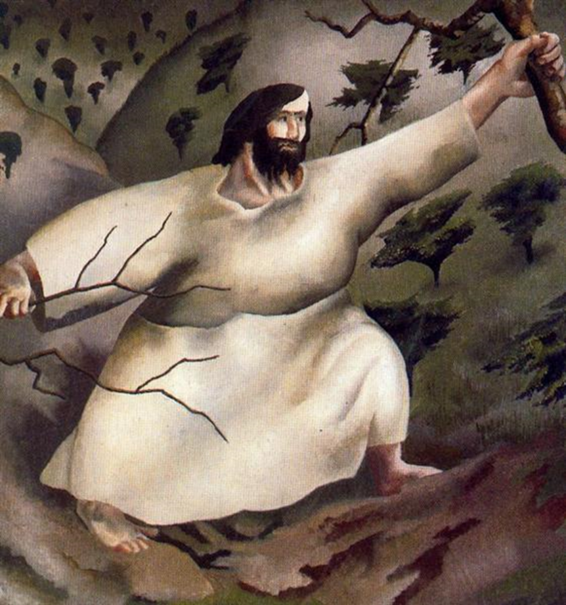
Stanley Spencer, Jesus in the Wilderness

MORNING SERVICE
LENT 1
21st February 2021

The Gathering

The Greeting

The Lord be with you
All And also with you

Hymn
1 Thou, whose almighty word
chaos and darkness heard,
and took their flight;
hear us, we humbly pray,
and where the gospel-day
sheds not its glorious ray,
let there be light.
2 Thou, who didst come to bring
on thy redeeming wing
healing and sight,
health to the sick in mind,
sight to the inly blind,
O now to all mankind
let there be light.
3 Spirit of truth and love,
life-giving, holy Dove,
speed forth thy flight;
move on the water's face,
bearing the lamp of grace,
and in earth's darkest place
let there be light.

4 Holy and blessèd Three,
glorious Trinity,
Wisdom, Love, Might;
boundless as ocean's tide
rolling in fullest pride,
through the earth far and wide
let there be light.

Prayer of Preparation

All Almighty God
to whom all hearts are open,
all desires known,
and from whom no secrets are hidden:
cleanse the thoughts of our hearts
by the inspiration of your Holy Spirit,
that we may perfectly love you,
and worthily magnify your holy name;
through Christ our Lord.
Amen.

Prayers of Penitence

The Commandments

Hear these commandments which God has given to his people, and examine your hearts.

I am the Lord your God: you shall have no other gods but me.
You shall love the Lord your God with all your heart, with all your soul, with all your mind, and with all your strength.
All Amen. Lord have mercy.
You shall not dishonour the name of the Lord your God.
You shall worship him with awe and reverence.
All Amen. Lord have mercy.

You shall not make for yourself any idol.
God is spirit, and those who worship him must worship in spirit and in truth.
All Amen. Lord have mercy.

Remember the Lord's day and keep it holy.
Christ is risen from the dead: set your minds on things above, not on things on the earth.
All Amen. Lord have mercy.

Honour your father and mother.
Live as servants of God; honour one another;
love the fellowship.
All Amen. Lord have mercy.

You shall not commit murder.
Be reconciled to your neighbour; overcome evil with good.
All Amen. Lord have mercy.

You shall not commit adultery.
Know that your body is a temple of the Holy Spirit.
All Amen. Lord have mercy.

You shall not steal.
Be honest in all that you do and care for those in need.
All Amen. Lord have mercy.

You shall not be a false witness.
Let everyone speak the truth.
All Amen. Lord have mercy.

You shall not covet anything which belongs to your neighbour.
Remember the words of the Lord Jesus: It is more blessed to give than to receive. Love your neighbour as yourself, for love is the fulfilling of the law.
All Amen. Lord have mercy.

The sacrifice of God is a broken spirit;
a broken and contrite heart God will not despise.
Psalm 51
Let us confess our sins in penitence and faith,
firmly resolved to keep God’s commandments
and to live in love and peace with all.

All Lord God,
we have sinned against you;
we have done evil in your sight.
We are sorry and repent.
Have mercy on us according to your love.
Wash away our wrongdoing
and cleanse us from our sin.
Renew a right spirit within us
and restore us to the joy of your salvation,
through Jesus Christ our Lord.
Amen. Based on Psalm 51

May the God of love and power
forgive you and free you from your sins,
heal and strengthen you by his Spirit,
and raise you to new life in Christ our Lord.
All Amen.

The Collect

The president introduces a period of silent prayer.
Heavenly Father,
your Son battled the powers of darkness,
and grew closer to you in the desert:
help us to grow in wisdom and prayer
that we may be witnesses to your saving love
in Jesus Christ our Lord.

All Amen.

The Liturgy of the Word

First Reading

Genesis 9:8-17
Then God said to Noah and to his sons with him, ‘As for me, I am establishing my covenant with you and your descendants after you, and with every living creature that is with you, the birds, the domestic animals, and every animal of the earth with you, as many as came out of the ark. I establish my covenant with you, that never again shall all flesh be cut off by the waters of a flood, and never again shall there be a flood to destroy the earth.’ God said, ‘This is the sign of the covenant that I make between me and you and every living creature that is with you, for all future generations: I have set my bow in the clouds, and it shall be a sign of the covenant between me and the earth. When I bring clouds over the earth and the bow is seen in the clouds, I will remember my covenant that is between me and you and every living creature of all flesh; and the waters shall never again become a flood to destroy all flesh. When the bow is in the clouds, I will see it and remember the everlasting covenant between God and every living creature of all flesh that is on the earth.’ God said to Noah, ‘This is the sign of the covenant that I have established between me and all flesh that is on the earth.’

For the word of the Lord.

All Thanks be to God.

Psalm 51

Second Reading

Mark 1:9-15

In those days Jesus came from Nazareth of Galilee and was baptized by John in the Jordan.

And just as he was coming up out of the water, he saw the heavens torn apart and the Spirit descending like a dove on him. And a voice came from heaven, ‘You are my Son, the Beloved; with you I am well pleased.’

And the Spirit immediately drove him out into the wilderness.

He was in the wilderness for forty days, tempted by Satan; and he was with the wild beasts; and the angels waited on him.

Now after John was arrested, Jesus came to Galilee, proclaiming the good news of God, and saying, ‘The time is fulfilled, and the kingdom of God has come near; repent, and believe in the good news.’
For the word of the Lord.

All Thanks be to God.

Affirmation of faith

Let us affirm our faith in Jesus Christ the Son of God.

All Though he was divine,
he did not cling to equality with God,
but made himself nothing.
Taking the form of a slave,
he was born in human likeness.
He humbled himself,
and was obedient to death,
even the death of the cross.
Therefore God has raised him on high,
and given him the name above every name:
that at the name of Jesus
every knee should bow,
and every voice proclaim
that Jesus Christ is Lord,
to the glory of God the Father.
Amen.
Philippians 2
Hymn
1 Forty days and forty nights
Thou wast fasting in the wild;
Forty days and forty nights
Tempted, and yet undefiled.

2 Sunbeams scorching all the day;
chilly dew drops nightly shed;
prowling beasts about thy way;
stones thy pillow, earth thy bed.

3 Shall not we thy sorrows share
And from worldly joys abstain,
Fasting with unceasing prayer,
glad with thee to suffer pain?

4 And, if Satan, vexing sore,
Flesh or spirit to assail,
thou, his vanquisher before,
Grant we may not faint nor fail!

5 So shall we have peace divine;
Holier gladness ours shall be.
'Round us, too, shall angels shine,
Such as ministered to thee.

6 Keep, O keep us, Saviour dear,
Ever constant by thy side,
That with thee we may appear
At the eternal Eastertide.

Prayers of Intercession
These responses may be used

Lord in your mercy.
All Hear our prayer.

Ending with

Merciful Father,
All Accept these prayers
For the sake of your Son,
Our Saviour Jesus Christ.
Amen.

The Lord’s Prayer

President Trusting in the compassion of God, let us pray
with confidence as our Saviour has taught us

All Our Father, who art in heaven,
hallowed be thy name;
thy kingdom come;
thy will be done;
on earth as it is in heaven.
Give us this day our daily bread.
And forgive us our trespasses,
as we forgive those who trespass against us.
And lead us not into temptation;
but deliver us from evil.
For thine is the kingdom,
the power and the glory,
for ever and ever.
Amen.

Hymn
1 Lead us, heavenly Father, lead us
o'er the world's tempestuous sea;
guard us, guide us, keep us, feed us,
for we have no help but thee;
yet possessing every blessing,
if our God our Father be.

2 Saviour, breathe forgiveness o'er us:
all our weakness thou dost know;
thou didst tread this earth before us,
thou didst feel its keenest woe;
lone and dreary, faint and weary,
through the desert thou didst go.

3 Spirit of our God, descending,
fill our hearts with heavenly joy,
love with every passion blending,
pleasure that can never cloy:
thus provided, pardoned, guided,
nothing can our peace destroy.

Blessing
Christ give you grace to grow in holiness,
deny yourselves, take up your cross, and follow him;
and the blessing of God almighty,
the Father, the Son, and the Holy Spirit,
be among you and remain with you always.
All Amen.

Go in peace to love and serve the Lord.
All In the name of Christ. Amen.

Common Worship: Services and Prayers for the Church of England, material from which is included in this service, is copyright © The Archbishops' Council 2000.

Rockland Benefice 2021.

