Rockland Benefice in the Bramerton Group

Morning Prayer

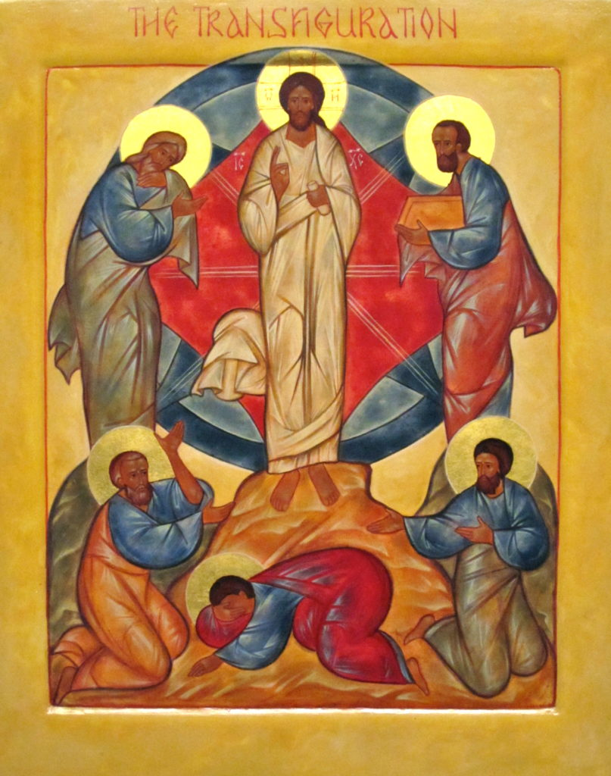

Transfiguration Sunday

14 February 2021

Preparation
O Lord, open our lips
All and our mouth shall proclaim your praise.
The people who walked in darkness have seen a great light; those who lived in a land of deep darkness – on them light has shined. Isaiah 9.2
This opening prayer may be said
The night has passed, and the day lies open before us;
let us pray with one heart and mind.
Silence is kept.
As we rejoice in the gift of this new day,
so may the light of your presence, O God,
set our hearts on fire with love for you;
now and for ever.
All Amen.
Hymn
1 Love divine, all loves excelling,
joy of heav’n, to earth come down,
fix in us thy humble dwelling,
all thy faithful mercies crown.
2 Jesus, thou art all compassion,
pure, unbounded love thou art.
Visit us with thy salvation;
enter ev'ry trembling heart.
3 Come, Almighty, to deliver,
let us all thy life receive.
Suddenly return, and never,
nevermore they temples leave.

4 Thee we would be always blessing,
serve thee as thy hosts above,
pray, and praise thee without ceasing,
glory in thy perfect love.
5 Finish, then, thy new creation;
true and spotless let us be.
Let us see thy great salvation
perfectly restored in thee.
6 Changed from glory into glory,
till in heav’n we take our place,
till we cast our crowns before thee,
lost in wonder, love and praise.
The Forgiveness of God
Your unfailing kindness, O Lord, is in the heavens,
and your faithfulness reaches to the clouds:
Lord, have mercy.
Lord, have mercy.

Your righteousness is like the strong mountains,
and your justice as the great deep:
Christ, have mercy.
Christ, have mercy.

For with you is the well of life
and in your light shall we see light:
Lord, have mercy.
Lord, have mercy.
God’s Forgiveness is declared.

The Word of God

Psalmody

Psalm 150
1Alleluia.
O praise God in his holiness; ♦
praise him in the firmament of his power.
2Praise him for his mighty acts; ♦
praise him according to his excellent greatness.
3Praise him with the blast of the trumpet; ♦
praise him upon the harp and lyre.
4Praise him with timbrel and dances; ♦
praise him upon the strings and pipe.
5Praise him with ringing cymbals; ♦
praise him upon the clashing cymbals.
6Let everything that has breath ♦
praise the Lord.
Alleluia.
All Glory to the Father and to the Son
and to the Holy Spirit;
as it was in the beginning is now
and shall be for ever. Amen.

First Reading Exodus 24.12-18
The Lord said to Moses, ‘Come up to me on the mountain, and wait there; and I will give you the tablets of stone, with the law and the commandment, which I have written for their instruction.’ So Moses set out with his assistant Joshua, and Moses went up into the mountain of God. To the elders he had said, ‘Wait here for us, until we come to you again; for Aaron and Hur are with you; whoever has a dispute may go to them.’
Then Moses went up on the mountain, and the cloud covered the mountain. The glory of the Lord settled on Mount Sinai, and the cloud covered it for six days; on the seventh day he called to Moses out of the cloud. Now the appearance of the glory of the Lord was like a devouring fire on the top of the mountain in the sight of the people of Israel. Moses entered the cloud, and went up on the mountain. Moses was on the mountain for forty days and forty nights.
For the Word of the Lord
All Thanks be to God.
Hymn

1 Tis good, Lord, to be here!
Your glory fills the night;
Your face and garments, like the sun,
Shine with unborrowed light.

2 Tis good, Lord, to be here,
Your beauty to behold
Where Moses and Elijah stand,
Your messengers of old.

3 Fulfiller of the past
And hope of things to be,
We hail your body glorified
And our redemption see.

4 Before we taste of death,
We see your kingdom come;
We long to hold the vision bright
And make this hill our home.

5 Tis good, Lord, to be here!
Yet we may not remain;
But since you bid us leave the mount,
Come with us to the plain.

Second Reading Mark 9:2-10
²Six days later, Jesus took with him Peter and James and John, and led them up a high mountain apart, by themselves. And he was transfigured before them, ³and his clothes became dazzling white, such as no one on earth could bleach them. ⁴And there appeared to them Elijah with Moses, who were talking with Jesus. ⁵Then Peter said to Jesus, “Rabbi, it is good for us to be here; let us make three dwellings, one for you, one for Moses, and one for Elijah.” ⁶He did not know what to say, for they were terrified. ⁷Then a cloud overshadowed them, and from the cloud there came a voice, “This is my Son, the Beloved; listen to him!” ⁸Suddenly when they looked around, they saw no one with them any more, but only Jesus.
⁹As they were coming down the mountain, he ordered them to tell no one about what they had seen, until after the Son of Man had risen from the dead. ¹⁰So they kept the matter to themselves, questioning what this rising from the dead could mean.
For the Word of the Lord
All Thanks be to God.
By the appearance on earth of our Saviour Jesus Christ
God has broken the power of death
and brought life and immortality to light.
Arise, shine, for your light has come
and the glory of the Lord has risen upon you.
For though darkness shall cover the earth
and thick darkness the nations,
the Lord will rise upon you
and his glory will be seen upon you.
By the appearance on earth of our Saviour Jesus Christ
God has broken the power of death
and brought life and immortality to light.
from Colossians 3

Prayers
In the power of the Spirit and in union with Christ,
let us pray to the Father.
Lord of glory, it is good that we are here.
In peace we make our prayer to you.
In trust we confirm our faith in you …
Help us to set our faces steadfastly to where you would have us go. Lord, look with favour.
Lord, transfigure and heal.

Lord of glory, look with favour on your Church,
proclaiming your beloved Son to the world
and listening to the promptings of his Spirit …
May she be renewed in holiness that she may reflect your glory.
Lord, look with favour.
Lord, transfigure and heal.

Lord of glory, look with favour on the nations of the world,
scarred by hatred, strife and war …
May they be healed by the touch of your hand.
Lord, look with favour.
Lord, transfigure and heal.

Lord of glory, look with favour on those in need and distress,
suffering as your Son has suffered
and waiting for the salvation you promise …
May the day break and Christ the Morning Star bring them the light of his presence. Lord, look with favour.
Lord, transfigure and heal.

Lord of glory, it is good if we suffer with you
so that we shall be glorified with you.
According to your promise bring all Christ’s brothers and sisters …
to see him with their own eyes in majesty
and to be changed into his likeness from glory to glory.
To him be praise, dominion and worship
now and for all eternity. Amen.
The Collect of the day is said
Almighty Father,
whose Son was revealed in majesty
before he suffered death upon the cross:
give us grace to perceive his glory,
that we may be strengthened to suffer with him
and be changed into his likeness, from glory to glory;
who is alive and reigns with you,
in the unity of the Holy Spirit,
one God, now and for ever.
All Amen.
The Lord’s Prayer is said
Let us pray with confidence as our Saviour has taught us
All Our Father, who art in heaven,
hallowed be thy name;
thy kingdom come;
thy will be done;
on earth as it is in heaven.
Give us this day our daily bread.
And forgive us our trespasses,
as we forgive those who trespass against us.
And lead us not into temptation;
but deliver us from evil.
For thine is the kingdom,
the power and the glory,
for ever and ever.
Amen.

The Conclusion

Hymn

1 Christ, whose glory fills the skies,
Christ, the true, the only light,
Sun of righteousness, arise,
triumph o'er the shades of night;
Dayspring from on high, be near;
Daystar, in my heart appear.
2 Dark and cheerless is the morn
unaccompanied by thee:
joyless is the day's return,
till thy mercy's beams I see,
till they inward light impart,
glad my eyes, and warm my heart.
3 Visit then this soul of mine;
pierce the gloom of sin and grief;
fill me, radiancy divine;
scatter all my unbelief;
more and more thyself display,
shining to the perfect day.

Blessing
Christ, whose glory fills the skies, fill you with radiance
and scatter the darkness from your path.
Amen.
Christ, the Sun of Righteousness,
gladden your eyes and warm your heart.
Amen.
Christ, the Dayspring from on high,
draw near to guide your feet into the way of peace.
Amen.
And the blessing of God almighty,
the Father, the Son, and the Holy Spirit,
be among you and remain with you always. Amen.

Rockland Benefice 2021
© The Archbishops' Council of the Church of England, 2000-2005
Official Common Worship apps, books and eBooks are available from Church House Publishing.
The Bible readings (other than the psalms) are from The New Revised Standard Version Anglicized Edition, copyright 1989, 1995 Division of Christian Education of the National Council of the Churches of Christ in the United States of America. Used by permission. All rights reserved.
Implemented by Simon Kershaw at Crucix.
Implementation copyright © Simon Kershaw, 2002-2020.

