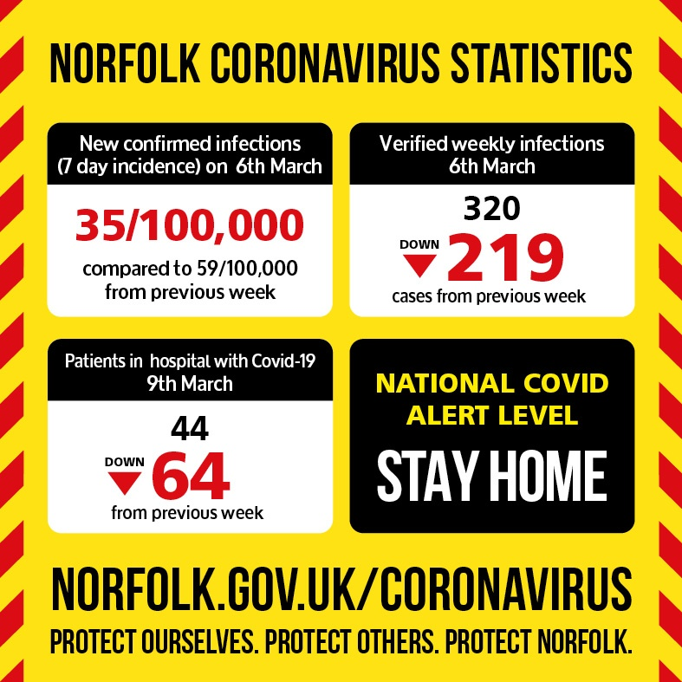
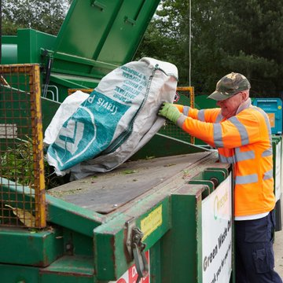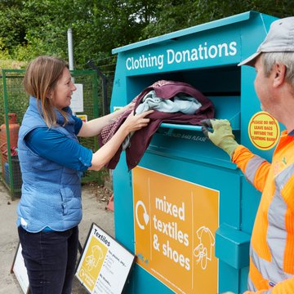
Tell us what you think about your local recycling centre in our satisfaction survey
http://nccfas.co/htltG We're always looking to improve your experience using them – and if you don’t use them, we want to hear from you so that we can understand why
Our annual recycling centre survey is an opportunity for you to tell us what's working well or what could be improved at your local centre. Even if you don’t use them, we want to hear from you so that we can understand why. Tell us what you think
http://nccfas.co/R2Or5
Work begins on Harford recycling centre of 22nd march to open in October 2021
Conservative led Norfolk County Council, in partnership with others, is helping 6,000 children to access online learning. So far we’ve already distributed over 2,500! https://www.norfolk.gov.uk/.../every-child-online...
Every school age child has a digital device and internet connection to learn remotely at home has been launched today.
Norfolk County Council is working with Norfolk Community Foundation (NCF) on the campaign backed by the EDP newspaper to make sure no child is left behind in their learning because of digital disadvantage.

The campaign gives two ways to step up and help
- Businesses and organisations can give pre-used corporate devices to the county council for refurbishment and distribution to schools. To donate email devices@norfolk.gov.uk
- Individuals and businesses can give funding to the NCF to be spent on new laptops and tablets and internet connections. To donate visit the NCF website.
But it is estimated that Norfolk’s 430 schools and academies still need around 6,000 devices and at least 1,000 households with school-age children are unable to connect to the internet.
Lots of organisations are still doing online learning, and will continue to do so, including NCC Libraries and so we still need more devices

Norfolk County Council is working to address the need and co-ordinate the immediate response
- The council’s Schools IT team has supported around 60 schools with either Microsoft or Google Platforms with more support ongoing
- The team’s certified trainers for Google Education and Microsoft Education Global have been supporting schools expertise via online training and webinars
- Norfolk Libraries service has been offering guidance and advice to families by creating ‘libraries at home’: with access to free eBooks, online resources and activities, and help to get online from library staff on the end of a telephone 01603 774777 from 10am-6pm Monday to Friday and 10am-4pm on Saturdays.
Flooding
Lord Dannett has already convened the Norfolk Flood Alliance
NCC and SNDC have flooding on their lists
County budget allocated 3.500,000 for flood related work

Free Composting For Beginners online workshops. Designed to help you get started or improve your composting you can now book your free workshop via the Home Composting Webinar Booking Form (google.com). The next dates are as follows:
Thursday 18th March 2021, 7pm – 8pm.
Thursday 25th March 2021, 2pm – 3pm.

- Scam Alert - Text Messages claiming to be from Royal Mail
- Scam Alert - Fake 'NHS COVID-19 relief grant' text messages
- Scam Alert - Automated telephone cold calls making claims about 'your National Insurance Number'
- Safety Alert - iCandy issues a product recall notice for two batch numbers (E11055 & E11074) of their iCandy MiChair
- Recall Alert - Boots has issued a Product Recall for their 'Boots Multivitamins 180 tablets' with the batch numbers 1805 & 1806 on sale between 12th & 19th January 2021 as they contain 'Multivitamins with Iron'
- Scam Alert – Automated telephone cold calls making claims about ‘your National Insurance Number’
- News Alert – BBC Watchdog report on unsafe electrical product
- Rogue Trader Alert – Doorstep Cold Callers in South Norfolk area
- Food Alert – Lidl GB recalls their ‘Crownfield Wholegrain Wheat Bixies 36’ with the Best Before End dates of 10/01/22, 11/01/22 & 12/01/22 due to the possible presence of small pieces of plastic in the product
- Safety Alert – River Island is recalling their ‘Mini Girl Black Triple Buckle Ankle Boots – product number 492953’ sold between October 2020 and January 2021 as the diamante stones may become loose and pose a choking hazard
- Safety Alert – Flying Tiger Copenhagen is recalling their ‘Car truck with cars wooden – item number 3019330’ sold between November 2019 and April 2020 due to a small part which can detach and pose a choking hazard
- Scam Alert – Fake Vodafone text messages
- Scam Alert – Telephone cold calls claiming to be from “BarclaysBank”
- Food Alert – Danone recalls 3 yogurt products as they may contain metal pieces
- Scam Alert – Fake prize offers don’t pay
- Rogue Trader Alert – Doorstep calling incidents
- Information Alert - Coronavirus NHS text

