Vic Thomson South Norfolk District Councillor’s report

Covid
Figures still low and we are easing down the route out of covid. However, we still need to take care. Get vaccinated, use Track and Trace and adhere to Covid safety measures.

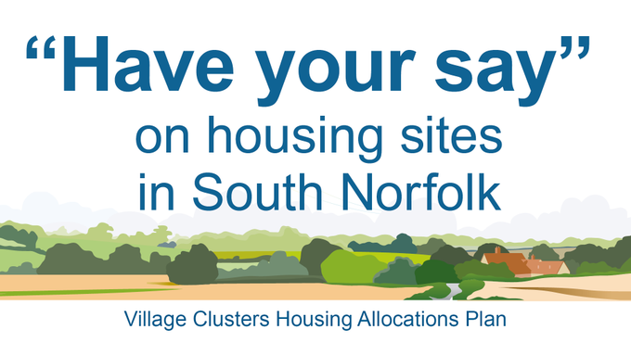
SNDC Clusters
South Norfolk Council is currently preparing a housing allocations document that will shape development within the district’s villages, identifying land for a minimum of 1,200 new homes. This plan will be called the South Norfolk Village Clusters Housing Allocations Plan (VCHAP).
These cluster sites are small sites spread around as opposed to large developments.
Based on school catchment areas

Village Clusters Housing Allocations Plan: Regulation 18 Public Consultation
When: 9am, Monday 7th June 2021 to 5pm, on Monday 2 August 2021
The ‘South Norfolk Village Clusters Housing Allocation Plan’ (VCHAP) has now been published for public consultation. In addition to the consultation document itself, a number of supporting documents have also been made available and there is an opportunity for new sites to be submitted to us for consideration.
This public consultation is an opportunity for you to provide us with your views on the sites that have been promoted to us, the assessments undertaken so far, our suggestions for overarching policies that would apply to these allocation sites and the supporting evidence that has helped to prepare the emerging Plan. You may also wish to tell us if you feel the development of a particular site needs to address a specific issue (for example, a footpath link). During this process we have also taken the opportunity to review the existing development boundaries (or ‘settlement limits’) throughout the district and your comments on proposed changes to these are also welcomed.
Virtual Exhibition
Our exhibition is being held online and you are invited to enter our virtual exhibition hall via the following link http://ow.ly/nQB650F4sOI
Within the exhibition hall you will find our display stands which set out the background to the VCHAP, you will be able to view the main consultation document and the supporting documents, including maps of the sites being considered, individual site assessments and a list of Frequently Asked Questions (FAQs).
Comments may be submitted to us using the ‘Have Your Say’ console. A planning officer will be available online via the webchat accessed in the exhibition hall between 10am and 2pm on a Tuesday and 2pm and 6pm on a Thursday throughout the consultation period.
Outside of these times you can contact us by phone between the hours of 8.30am and 5pm or via email using the contact details listed below.
Consultation Document
You can comment on the consultation material directly at the following link - https://south-norfolk.oc2.uk. Please note that in order to submit your feedback you will be required to register your details in the system.
If you have a new site that you wish to promote to us please do so by completing the Call for Sites Form, which can be found here - https://south-norfolk.oc2.uk/document/3. It will be useful for you to consider the Council’s Assessment Criteria when completing the site submission form. The Assessment Criteria is published as a supporting document to the consultation. If you require assistance completing the Call for Sites Form please contact a team member who will be able to assist you.
Please see the Privacy Statement for details about how your data will be used if you wish to be added to our consultation database.
Next Steps
Following this public consultation, the Council will review its conclusions on sites in light of the representations received, assess any new sites that have been submitted and carry out any further fact finding or evidence gathering that is necessary. Once this process is complete the Council will prepare the final, proposed submission (or Regulation 19) version of the plan.
The public and other stakeholders will have an opportunity to comment on whether the proposed submission version of the plan meets the legal and policy compliance tests set out by government before it is submitted to the Secretary of State for independent examination. Any representations made at this stage will be passed to the independent inspector who will examine the plan.
Following its independent examination, the plan is expected to be finalised and adopted in 2023.
Contact Us
If you have any difficulties accessing the documents online, accessing different areas of our virtual exhibition or submitting your comments then please contact the team on (01508) 533805 or at lp@s-norfolk.gov.uk.
The draft 'South Norfolk Village Clusters Housing Allocation Plan' has now been published. View the virtual exhibition, the preferred development sites and have your say at: http://ow.ly/nQB650F4sOI
Windfalls
Broadband
We want to create a Community Broadband Scheme to give residents in your parish access to the Governments Rural Broadband Connectivity Scheme. The Scheme is to give rural areas access to superfast broadband by connecting Fibre to their house.
We have already completed a funded scheme in Yelverton and in Poringland.
There are three main broadband routes to a property
- Copper to the cabinet (ADSL) and then copper to the house, terribly slow up to a maximum of 14mbs, speed and stability reducing with distance
- Fibre to the cabinet (FTTC) and then copper to the house is fast usually up to a maximum of 80mbs, speed and stability reducing with distance
- Fibre to the house (FTTP) is superfast up to 900mbs. Fast and reliable.

Currently the properties within your parish are on option 2, this scheme will take them to option 3.
We are looking to connect Bramerton, Rockland and Surlingham within the same scheme
The membership of the group is from their connection to a BT Exchange and only residents attached to that cabinet can be included in this scheme.
This is a voucher scheme, and the Government provides a voucher of £1,500 for every residential property signed up to the scheme and £3,500 if that property has a business connected to that address including self-employment. An Inland Revenue UTR is required for confirmation of the business at the address.
We are waiting for the costing from Openreach for the scheme, the cost should easily be met through the voucher scheme detailed above. We would like to be able to ensure that all properties are able to obtain this service, so the more people who sign up the better.
Recent events have shown that a fast and reliable broadband is vital for the future. We would ask that you please promote this scheme within your parish and the more people you can connect the surer we can be of getting the scheme built out. If your property is within the scheme, please register and let people know that you have registered.
Could you please check your cabinet and speed.
It would help me to see the cabinets to which you are connected and your speeds.
Go to following link, follow the instructions and send me screen dump or cabinet number
https://www.broadbandchecker.btwholesale.com/#/ADSL
Rangers on the Broads
An article from the Norfolk magazine about a broads ranger
https://www.greatbritishlife.co.uk/people/norfolk-broads-ranger-boat-patrol-8037338
Brown bins
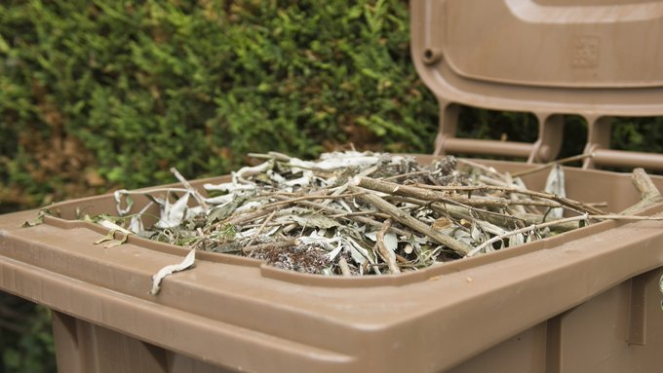
Please avoid pouring water into your garden waste bins. This can cause a number of problems including bins becoming very heavy, splitting, damaging the lifter and becoming a fire risk when water takes sap and slurry into the gullies and troughs.

Census

Census 2121 The response to Census 2021 has exceeded all expectations, with 97 per cent of households across England and Wales responding to the census.
This is above the pre-census target of 94 per cent, while all local authorities have seen over 90 per cent of households respond, exceeding an 80 per cent target.
Kerry Skelding, our Census Engagement Manager, told us that the response rate across Norfolk had been fantastic and exceeded expectations. The ONS is very happy with the outcome despite the challenges COVID presented.
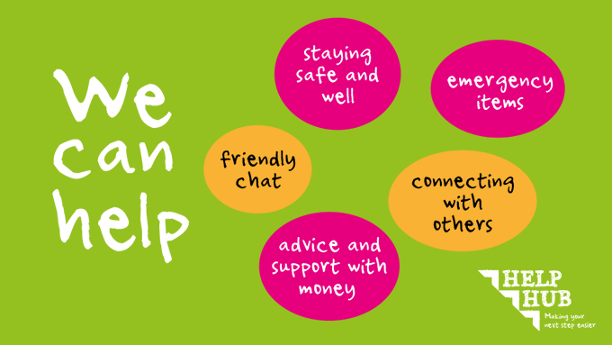
The Help Hub is a partnership between organisations that supports people in Broadland and South Norfolk. We can offer practical support, suggest community groups, and offer advice & guidance to get you back on track, whatever the situation. Find out more: http://ow.ly/9UW150F7nRA

