Covid
Still with us and as things ease we all still need to take care.
2nd highest in Norfolk, above regional and national levels.
Winter Strategy
Government announced its five pillars strategy for handling COVID-19 over the winter.
Norfolk County Council leader Councillor Andrew Proctor said: “The success of the vaccination programme has been a major part of the country’s response to Covid. I welcome the clarity that the Prime Minister has provided, regarding booster vaccinations for the over 50s and the 5 point plan and measures proposed to manage any increase in cases over winter. I support completely having a contingency plan if the NHS comes under unsustainable pressure.
“Winter is always a challenging time for health and care services and the potential for more Covid and flu cases shows the need for continued vigilance by all of us. Even people who have been double jabbed can catch Covid and get ill which is why it’s essential everyone gets vaccinated.
“I continue to urge people to follow the hands, face, space advice, to take lateral flow tests twice a week, to keep buildings well ventilated and wear masks where appropriate. Please follow self-isolation advice, if you do test positive.
“The pandemic is far from over but based on how sensibly most people in Norfolk have acted, thinking of others to control the spread of the virus, I’m confident that this is the way we will continue, to face down the worst risks this winter. We want to ensure we can both respond to the virus and recover from it by keeping our economy open and hopefully avoid any further lockdowns”
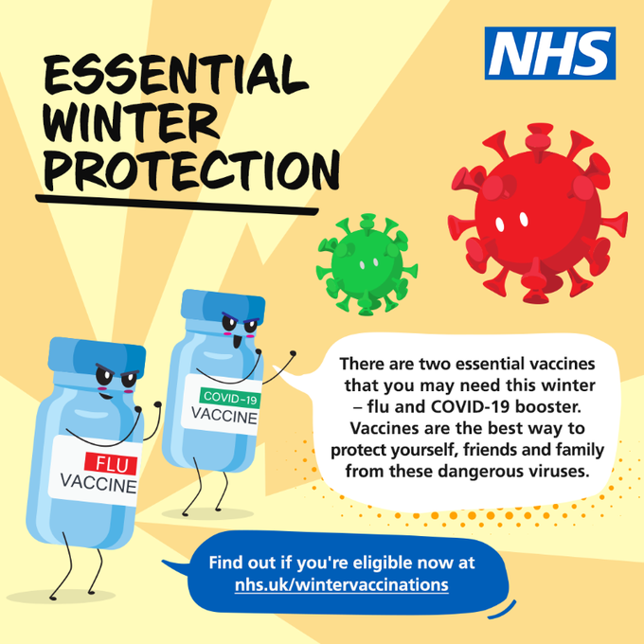
Lasting Memorial for Every Town and Parish Council
The work of communities across the county, which pulled together in the challenging times of the pandemic, is being recognised with a lasting memorial.

Lady Dannatt, Her Majesty’s Lord-Lieutenant for Norfolk, has commissioned a plaque for every parish and town council in the county using the design skills of Ruby Douglass and the wording from a team at Norwich’s National Centre for Writing.

Ruby, who is a recent graduate from Norwich University of the Arts, said: “The design relies heavily on the lettering traditionally associated with memorialising events and people. The style of lettering and shape of the plaque were chosen as a visual way to celebrate the community overcoming such a difficult year.”

The team at Norwich’s National Centre for Writing, led by Chris Gribble, researched a number of options and finally put forward the inspiring words of the Norfolk-born sociologist, Harriet Martineau: ‘Live your best and act your best and think your best today.’

Lady Dannatt said: “Many of the Deputy Lieutenants in Norfolk experienced at first hand the work of their local community during the height of the pandemic. A small group of them came together for this project and have worked through every stage to this point where every parish and town council can now receive their plaque and I am very grateful for their time and commitment.”

Deputy Lieutenants closest to each parish or town will distribute the plaques over the coming months.

The cost of the project has been covered by generous sponsorship from Adnams, the Red Socks Charitable Trust, the Geoffrey Watling Charity, the Pennycress Trust, the Kip and Alison Bertram Trust and the Sybil Cholmondeley Trust.

Parish and town councils, which have not made an application for a plaque already, should email: Wellbeing@NorfolkALC.gov.uk
Dear Library Customer,

From Monday 1 November, we will stop automatically renewing items borrowed from Norfolk libraries and will be asking you to renew or return your own items again.
This will allow you and other library users to have the widest possible range of options available when you visit one of our libraries.
However, we will not be reintroducing overdue charges at the same time, to give you some time to get back into the habit of managing your library loans.
If you want to manually renew an item from 1 November you can:
- Renew your item online
- Visit a library - use a self-service kiosk or ask a member of staff
- Call 0344 800 8020
If you want to return an item, then there is no need to wait until 1 November. Please use the drop box or self-service kiosks at your local library.
Thank you for looking after our books - we hope you’ve enjoyed reading them!
A47
Please find a link below the link to today's A47 campaign tweet for retweeting/further advertising if you so wish.
Norfolk County Council on Twitter: "National Highways want to know if you experience congestion, have safety concerns and where you see opportunities for better facilities on the A11 or A47. Fill in the survey today: https://t.co/JZwCGysIVX #justFUNDit #justDUALit https://t.co/31ILMpcSDt" / Twitter
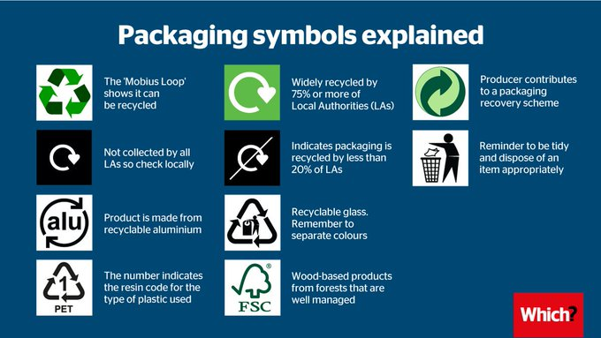
Making four shampoo bottles from recycled materials uses the same energy as making one from scratch. Most of us are stepping it up to take climate change down, and recycling is one of the easiest ways to do it.
https://www.recyclenow.com/recycle-week-2021
https://www.terracycle.com/en-GB/brigades
Recycling Centres

Harford bridge, replacing Ketteringham. This is to seek permission for a proposal to change the building construction from steel to brick. Unfortunately the national material shortage has made delivery of materials for the reuse shop and office buildings difficult and we are proposing to change from a steel building to a brick building,

North Norwich (by airport).
The brand-new Norwich North recycling centre is due to open for the first time on Wednesday 22 September. It will be the largest in the county, and is part of our multi-million pound programme of investment to improve recycling centres across the county.
This week we’ll also be saying a last goodbye to the old Mile Cross recycling centre which closes its doors for the final time at the end of the day on Thursday, 9 September. If people are not able to hold onto their recycling for a short while – there will be a number of alternative recycling centres that will be open as usual – more details here: https://orlo.uk/TfgnO
There are no plans to close Bergh Apton Recycling Centre and the intention is for Norwich South (Harford) to replace Ketteringham Recycling Centre only. Mile Cross Recycling Centre is due to close in September and will be replaced by the Norwich North and South Recycling Centres. Any recycling centre closures would be subject to consultation and member approval.
Lots of appeals for Afghan refugees
https://www.norfolk.gov.uk/what-we-do-and-how-we-work/norfolk-county-council-news-and-updates/afghan-resettlement
EV
A new electric vehicle strategy is set for discussion next week as county councillors consider practical ways to help boost the uptake of carbon cutting electric vehicles across Norfolk.
In April there were already 2,631 electric vehicles registered across Norfolk, however there are big differences between parts of the county with 22% of those in South Norfolk and only 5% in Great Yarmouth. There are also relatively few public chargers, with Norwich home to 44 of the 198 currently across Norfolk as a whole.
Cllr Barry Stone, Chair of the Infrastructure and Development Select Committee and Member Champion for Carbon Neutrality 2030, said:
“We are looking to make sure that the benefits of switching to electric vehicles are realised as quickly as possible in the county. Switching to electric vehicles has been identified in the latest draft Local Transport Plan as one of the most effective policies in reducing carbon emissions from transport.
“While we can’t make that happen on our own, the strategy identifies things that we can do to accelerate take up and help remove some of the barriers to electric car ownership, specifically regarding charging.
“We want to make it easier for people to charge their electric cars at home, seek funding for more public charge points in Norwich, and make it easier for local communities to access public chargers across the county.”
The electric vehicle strategy is one part of the work underway by the county council to achieve its ambitious target of net zero carbon by 2030. The strategy will complement other sustainable transport initiatives to boost active travel and cut carbon outputs, such as the hire schemes for e-scooters and e-bikes in Great Yarmouth and Norwich, and new zero emission buses.
The report to be considered by the committee highlights that the county council can play an important role in helping to increase the uptake of electric vehicles by not only ensuring that the necessary charging infrastructure is in place but also by setting a good example to local businesses and organisations as a result of electrifying its own fleet.
- Scam Alert – Emails claiming to be from ‘DVLA’ – 29 July 2021
- Scam Alert – Fake text messages from Hermes – 29 July 2021
- Food Alert - KP Snacks recalls Popchips Sea Salt flavour because of undeclared milk
- Food Alert - Lung Wah Chong recalls several Jelly cup products because of a choking hazard
- Scam Alert – Telephone cold calls claiming to be from NHS
- Scam Alert – Fake competitions on Facebook
- Scam Alert – Scammers posing as your email or phone contacts to request money
- Cold Calling Alert – Rogue traders offering roofing repairs
- Scam Alert - Covid Passport Scam claiming to be from the NHS– 12 August 2021
- Scam Alert - Various correspondence – WHO Lottery Scam - 12 August 2021
- Cold Calling Alert – Telephone cold calls regarding ‘loft insulation’ – 19 August 2021
- Scam Alert – Covid 19 Test Ordering Texts – 19 August 2021
- Scam Alert – Texts Emails regarding ‘Lloyds Fraud Alert’ – 19 August 2021
- Scam Alert - Investment Scams and fake cryptocurrency exchanges – 26 August 2021
- Scam Alert – ‘Brushing’ scams – 26 August 2021
Scam Alert - Inheritance Scam Letter - 24 August 2021
- Sainsbury’s recalls On the Go Spicy Chicken Pasta because of undeclared milk
- Tayto Group recalls some Mr Porky, Jay’s and The Real Pork Crackling Company products because of the possible presence of salmonella
- Lidl recalls Parkside Steam Wallpaper Stripper
- Scam Alert – ‘Phishing’ scams – 02 September 2021
- Cold Calling Alert – Telephone cold calls from “Citizens Advice” – 02 September 2021
- Cold Calling Alert – Telephone cold calls regarding appliance warrantees or insurance
- Cold Calling Alert – Doorstep Cold Callers offering ‘free insulation assessments’
- Scam Alert – Emails offering your ‘COVID 19 Travel Certificate’
- Safety Alert – Card Factory recalls their ‘Wonderful Teacher’ Trad Mug sold between May & August 2021 due to the product incorrectly being labelled as ‘microwave safe’
- Food Alert – SFC Wholesale Ltd are recalling their ‘The Original SFC Bargain Box 700g’ due to the presence of buttermilk which is not declared on the packaging
- Rogue Trader Alert – Doorstep Cold Callers offering gardening work in the Hellesdon area – 23 September 2021
- Scam Alert – Be alert for bogus energy salespeople – 23 September 2021
- Rogue Trader Alert – Doorstep Cold Callers selling household products – 22 September 2021
- Cold Calling Alert – Telephone cold calls regarding ‘gas contracts’ – 22 September 2021

