SNDC report
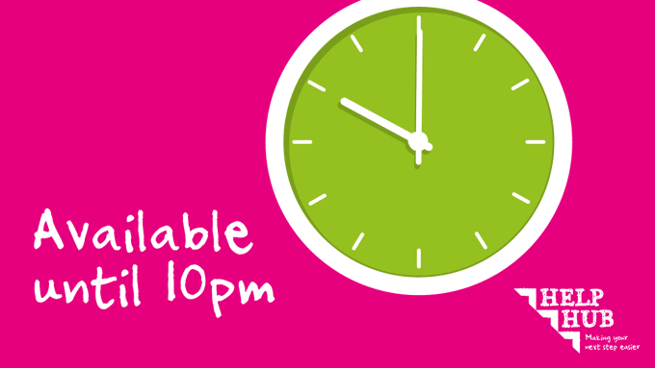
Our Help Hub phone lines are available from 8.15am to 10pm Monday to Friday so you can get advice and support when you need it. Call us on 01508 533933 Find out more about how the Help Hub can support you http://ow.ly/xTE750F7x8Z #WeCanHelp #HelpHub

#RediscoverNorfolk with Norfolk Trails tried & tested circular walks to explore your local patch – you’ll be amazed at the hidden places you can find on foot: https://orlo.uk/ajTsV
Getting out in nature is one of the most powerful ways to good health and well-being. Start with a small walk or try a longer hike, either way lots of children are totally ready to release their inner wild child! And perhaps you are too?


You can make a real difference to children’s lives as a school governor.
Anyone can be a governor – you don’t need to be a parent or work in education. We’re looking for people from a range of backgrounds and life experience.
Being a school governor is a commitment, but it also brings huge rewards. If you’re over 18 and keen to share your insight and skills to benefit young people, we’d love to hear from you.
You’ll bring your own skills to school and gain more as you get involved in all aspects of running a school. We’ll give you induction training to get you started there’s ongoing training too.
Find out how you can support a Norfolk school: https://orlo.uk/BecomeAGovernor_nBnP0

Norfolk Fire and Rescue Service: The service is joining a national #KnowExactlyWhere campaign next week to highlight the benefits of using the app What3Words – which helps them to locate emergency incidents quickly and easily. What3Words divides the world up into 3m x 3m squares and if emergency callers are able to give such a location, rescue teams can target resources to the exact spot quickly- particularly helpful with rural incidents. You can watch a short video here about it https://youtu.be/NHEjeUj-IXE Norfolk Fire and Rescue Service would encourage you to download the app and spread the word.

Please don't put batteries in your recycling bin; we have heard of several fires recently caused by batteries! Batteries can be recycled at any of Norfolk's Recycling Centres and many supermarkets or other retails who sell batteries. http://ow.ly/Zp8l50FuMnh

Highway Code
New changes to the Highway Code will create a "hierarchy of road users" in a bid to boost the safety of pedestrians and cyclists.
Transport Secretary Grant Shapps announced the updates, to be included in a new version of the Highway Code being published in the autumn, as part of a £338m package to boost cycling and walking.
In an effort to capitalise on the walking and cycling boom during the COVID pandemic, the government will also boost funding for the construction of hundreds of miles of new cycle lanes, improvements to the National Cycle Network, and the delivery of new schemes to encourage walking.
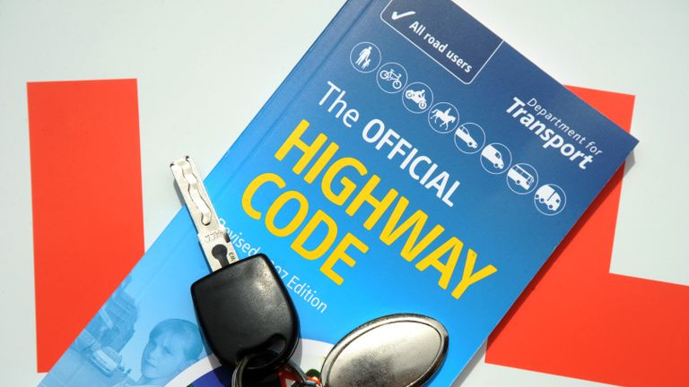
A new version of the Highway Code will be published in the autumn

The planned changes to the Highway Code include:
• A hierarchy of road users that ensures road users who can do the greatest harm have the greatest responsibility to reduce the danger they may pose to others
• Strengthened pedestrian priority on pavements and at zebra crossings
• Guidance on safe passing distances and speeds and ensuring that cyclists have priority at junctions when travelling straight ahead.
Advertisement
It is understood the "Dutch reach" method for opening vehicle doors will also be included among the changes, as has been proposed by cycling campaigners to prevent cyclists being hit by opened doors.
This will see vehicle drivers and passengers urged to use their far hand to open a door, rather than the hand closest to the door, thereby requiring them to swivel and encouraging them to look behind for any oncoming traffic.
Video of changes
https://www.facebook.com/watch?v=159996376305177
School Governor
You can make a real difference to children’s lives as a school governor.
Anyone can be a governor – you don’t need to be a parent or work in education. We’re looking for people from a range of backgrounds and life experience.
Being a school governor is a commitment, but it also brings huge rewards. If you’re over 18 and keen to share your insight and skills to benefit young people, we’d love to hear from you.
You’ll bring your own skills to school and gain more as you get involved in all aspects of running a school. We’ll give you induction training to get you started there’s ongoing training too.
Find out how you can support a Norfolk school: https://orlo.uk/BecomeAGovernor_nBnP0

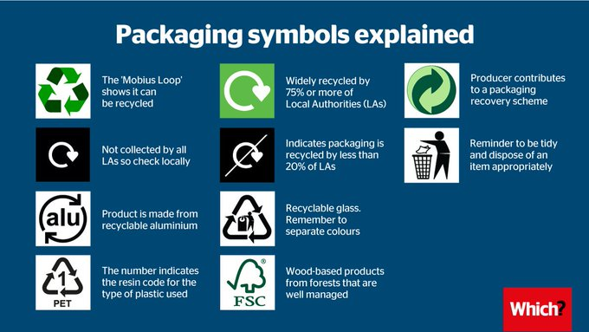
Making four shampoo bottles from recycled materials uses the same energy as making one from scratch. Most of us are stepping it up to take climate change down, and recycling is one of the easiest ways to do it.
https://www.recyclenow.com/recycle-week-2021
https://www.terracycle.com/en-GB/brigades
Lots of appeals for Afghan refugees
https://www.norfolk.gov.uk/what-we-do-and-how-we-work/norfolk-county-council-news-and-updates/afghan-resettlement

