Norfolk County Council – November Report

Covid, still around
Stay safe, hands face & space

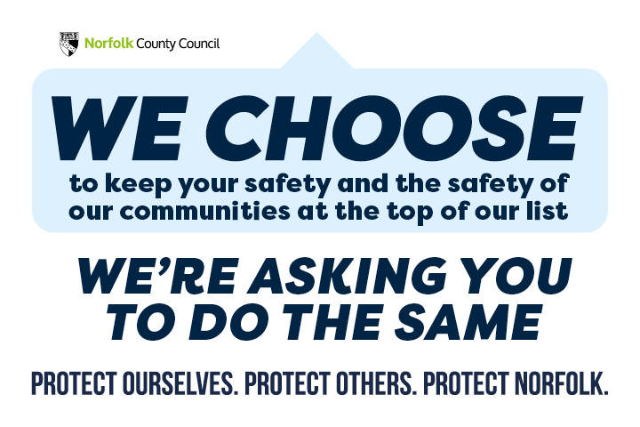

Bus Service Improvement Plan (BSIP) for Norfolk
Will be sent to the DfT, along with a request for £106m to achieve the aspirations set out within the Plan. I wanted to share with you a copy in advance, which I hope you will agree will deliver vast improvements in public transport for Norfolk’s residents.
The BSIP is the first part of a requirement from the government, as part of their national Bus Strategy announcement in March this year, to form an Enhanced Partnership with bus operators to deliver bus service improvements and increase the number of people using public transport. The full document is attached but in summary we want to make public transport an attractive and easy-to-use mode of transport by:
- Offering fares promotions to encourage people to try the bus e.g. £1 per journey for a week
- Offering reduced fares for those aged under 25
- Increasing the frequency of buses, particularly on key corridors
- Providing additional services in the early morning, evenings and at weekends
- Providing more services in places that currently have a poor service or none at all
- Improving facilities and information at bus stops and interchanges
- Increasing the number of bus priority measures like bus lanes to improve journey times
- Introducing a multi-operator ticket to use across all operators
- Fare capping – so that you pay a maximum amount for your journey if you use several services
- Implementing consistent service standards through an all-operator customer charter
- Developing a single information portal and journey planner
- Providing audio and visual next-stop announcements on buses
- Introducing greener and zero emission buses
The tight timescale that we working to meant that we were unable to fully consult on the plan, but we have put this together in partnership with all local bus operators and taking into consideration the comments and views of various stakeholders that we have been made aware of over recent years and looking at research done with passenger groups. It does not go into specifics about each area – instead it is a high-level aspirational document and once we know the level of funding that Norfolk will receive, we will be able to start the more detailed work of defining the exact measures and schemes that could be implemented in Norfolk. This is when we will be actively engaging with local areas through parish councils, district councils, yourselves and other key stakeholders so that they can contribute to making public transport better for their residents.
The next stage is to develop and publish an Enhanced Partnership Plan, which has to be done by 1 April 2022. More details about the National Bus Strategy (Bus Back Better) are here

SENT ON BEHALF OF THE NORFOLK STRATEGIC FLOODING ALLIANCE (NSFA)

The Norfolk Strategic Flooding Alliance (NSFA) has formally adopted an overall Strategy, designed to enable county wide responses to flooding across all agencies involved.
The Strategy, which lays out the NSFA’s vision, objectives, approach and structure, is a major milestone in the development of the Alliance, which was founded earlier this year to bring together all agencies and partners involved in planning for and responding to flooding in Norfolk.
The Strategy’s formal adoption comes on the day of the NSFA’s first joint exercise, Exercise TEMPESTAS, which examined in depth how the NSFA’s members will work together in the face of a major flooding incident, from the initial Met Office Flood Warning through to the Recovery phase. The exercise allowed Alliance Members to assess their readiness for flooding and to identify any weaknesses to be addressed or opportunities that could be taken to ensure all members are ready to work closely in the event of flooding this winter.

The Alliance’s Strategy is also accompanied by an Action Plan that identifies what steps the NSFA and its members are taking to address the risk of flooding. This includes work on individual sites across Norfolk, looking at working out costed solutions to address flood risk on each site and identify potential funding for each one: this work is already underway on an initial selection of sixteen flood sites in Norfolk, with a second tranche of sites being considered. The Strategy as adopted is attached:

Over recent weeks all of the members of the NSFA have ratified the Strategy, setting the Alliance on firm footing as it moves into its first autumn and winter. The focus of the NSFA is to drive collective ownership of flood risks and work collaboratively to minimise the impacts.
General Lord Richard Dannatt, Chair of the NSFA, said: “This Strategy shows the hard work that’s gone into the NSFA’s mission since it was founded earlier this year: as we move into the Alliance’s first winter, it puts us in a strong position to continue pushing for the investment and the joined up thinking needed to tackle flood risk in our county. Our first exercise, TEMPESTAS, has put that joined up thinking to the test, and will help us identify how we can be better prepared and what new opportunities for partnership working the Alliance has given us.

“But local preparedness and planning is only part of what’s needed: we will also be making the case to the government that the Planning system needs to recognise the importance of ensuring that development does not exacerbate the risk of flooding, either to existing residents and businesses or new ones. Addressing flooding and flood risk is something that needs coherent action from the parish level right up to the government.”

The Strategy sets out the NSFA’s vision, to coordinate the actions of all parties involved in flood response, from the statutory authorities, through to commercial companies, land owners and local communities. The aim is to ensure the people of Norfolk have confidence that flood risks are as low as reasonably practicable and will be well managed.

To achieve this, the Strategy also provides a clear approach and structure for the Alliance, to allow all its members to work together confidently and coherently both to address flood risk and to respond to flooding itself.

Peter Simpson, CEO of Anglian Water said, “The Norfolk Strategic Flooding Alliance has done a fantastic job bringing together all agencies across Norfolk who have the responsibility to tackle flooding. The strategy shows how vital collaborative working is to address the growing challenges we face from a changing climate. Flooding is a complex issue, and only by coming together can we work collectively to identify the most suitable investment opportunities to mitigate future risk.
“We know the East of England will be affected by climate change more keenly than anywhere else in the UK, which is why we’ve made a commitment to building a resilient water and waste water network fit for the future. As part of the NSFA, we’ll continue to work with others to ensure the best outcome for local communities across Norfolk.”

The adoption of the strategy comes a month after Norfolk County Council’s Cabinet agreed the allocation of a £1.5m flood reserve fund, including funding for several aspects of the NSFA’s work.

As autumn sets in, the single phone number set up by the NSFA to give Norfolk residents one point of contact to report flooding is expected to see increased use. The number is available for anyone wishing to report flooding anywhere in the county: they can simply call 0344 800 8013.

The Alliance includes, among others, the Environment Agency, Anglian Water, the Association of Drainage Authorities, the Water Management Alliance, Water Resources East, the Norfolk Resilience Forum, the Broads Authority and Norfolk’s County, Borough, City, District and Parish Councils.
NSFA Strategy-Ratification Draft.pdf

Scams
- Cold Calling Alert – Telephone cold calls regarding ‘loft insulation’
- Scam Alert – Telephone cold calls claiming you are ‘due compensation’
- Scam Alert – International FIFA World Cup Online Lottery Letters
- Scam Alert – ‘Free Trial Offer’ adverts
- Rogue Trader Alert – Doorstep Cold Caller selling Furniture
- Food Alert – Waitrose is recalling their ‘Waitrose Belgian Dark Chocolate with Raisins & Almonds’ as it may contain hazelnuts which are not mentioned on the label
- Safety Alert – LIDL is recalling two models of their ‘Playtime Safari Toys’ due to a possible safety risk which may pose a choking hazard

