South Norfolk District Council - 2 Councils, one team
We are reviewing policies to the 2 District Councils use the best policies.
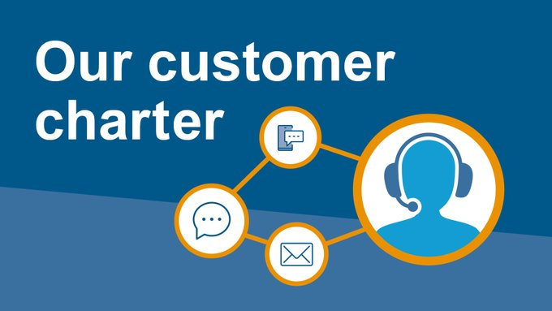
https://www.southnorfolkandbroadland.gov.uk/customercharter
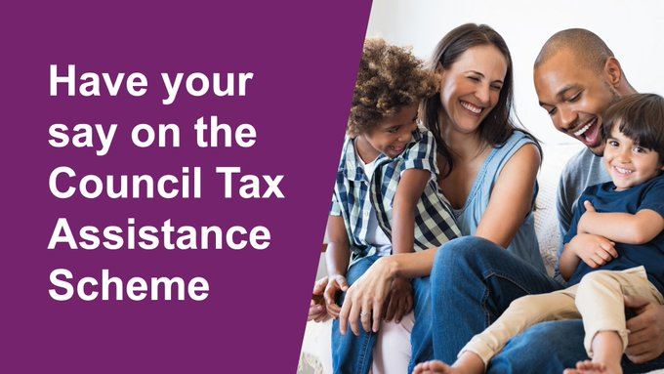
Since 1 April 2012 we have been operating a local Council Tax Assistance Scheme (CTA) which replaced Council Tax Benefit. Each year, we review and approve the scheme. To help us do this, we want to hear your views on the scheme. Have your say at: http://ow.ly/K4KP50G9Jow

Covid
Still high rates in SNDC, please take care.
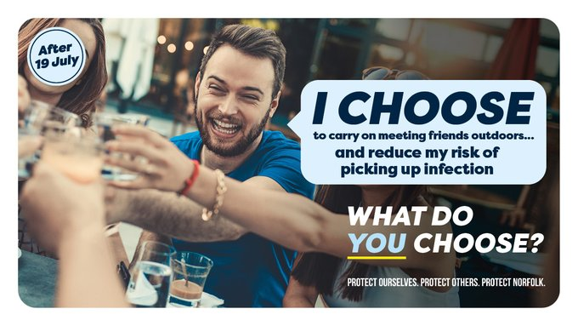
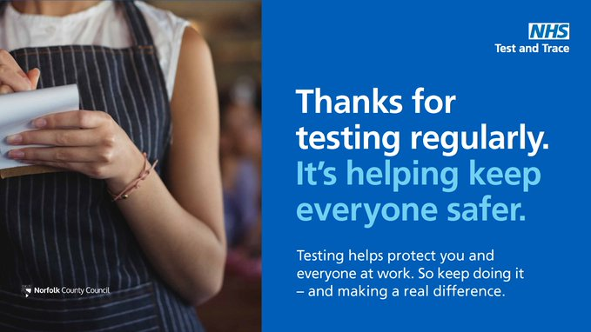Lateral flow tests are free, fast and easy to use. Testing regularly can help you protect your colleagues and break the chains of transmission. Testing packs are still free to collect from pharmacies with a collection QR code. Get yours now: https://orlo.uk/Testing_xhU00
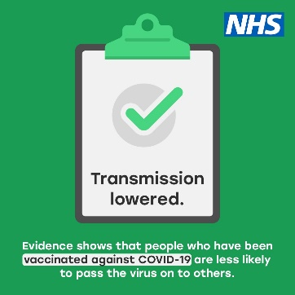
Evidence shows that people who have been vaccinated against COVID-19 are less likely to pass the virus on to others. Book an appointment today - http://ow.ly/8NRa50Gw8hy
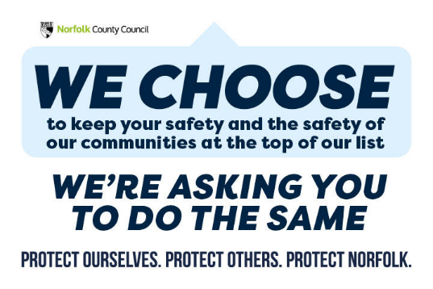

Do you know a shop or hospitality business that needs help?
Apply in November. Improvement grants are available for shop fronts and hospitality business exteriors. We’re looking for applications to be with us during November, especially if you need planning permission. Check if you are eligible and to apply http://ow.ly/EIEl50Gyh2L

Broadband
Superfast broadband is the newest utility and important in so many facets of our everyday life. I am at the very early stage of bringing very superfast broadband, called fibre to the property (fttp), to all the properties in Claxton and some neighbouring villages.
At the moment you have access to fast broadband but the further you live from the green cabinet the more your speed drops, this does not happen with fttp. This is a Government Voucher scheme, and we will be able to get fttp free to all properties.
I have the address dump from Openreach and they are costing the project. When we know the cost, we can work out how many houses we need to sign on to get enough to pay for the whole build out.
I have found the following Claxton postcodes but have more to check.
7AA, 7AS, 7AT, 7AU, 7AX, 7HY, 7HZ, 7UG and 7HU at Claxton Corner.
Will share as soon as have completed the transfer
The Christmas Campaign for High Streets The Gift Label campaign has been developed as part of the Reopening the High Street Safely Fund programme. The objective is to encourage and persuade shoppers to step into our local shops for some or all their Christmas gift shopping. The campaign aims to inspire people with ideas on what they can buy and where. ← A mixed media campaign – social media, shop windows, on-street and Council magazines. ← The campaign icon is a Gift Label with the text Love Local Christmas Gifts and gold stars, holly and gold ribbon. ← Shop managers will be offered large labels to hang in shop windows and doorways and smaller ones to hang in their shop if they wish. ← A gift hamper containing goodies and vouchers will be collected from shops and offered as a prize draw, one per district to be delivered in time for Christmas Day. ← Campaign images for social channels will feature the labels attached to gifts to act as inspiration for what you can buy and where. ← Circulation of materials to the High Street and the digital campaign will start from the beginning of November. Petra Boyce, Marketing & Communications Officer petra.boyce@southnorfolkandbroadland.gov.uk

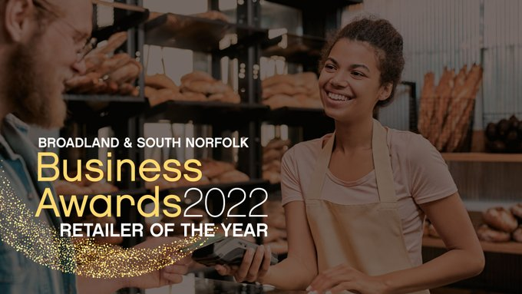
Nominate your favourite retailer in Broadland or South Norfolk for your chance to WIN £100 of vouchers to spend at a local independent shop of your choice (T&Cs apply): http://ow.ly/S8kO50GATBv #BSNBizAwards #RetailerOfTheYear #ShopLocal #Broadland #SouthNorfolk #Win

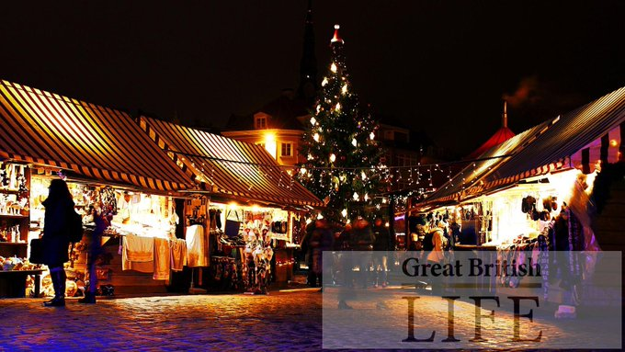
This month sees a whole wealth of #ChristmasMarkets popping up! #Norfolk #NorfolkMagazine

**Reminder**
If you are thinking of buying an E-Scooter as a Christmas present this year. Did you realise/know that by law, a privately bought E-scooter cannot be ridden on the road or pavement? Find out more here >https://norfolk.police.uk/advice/roads-and-vehicles/e-scooters-laws

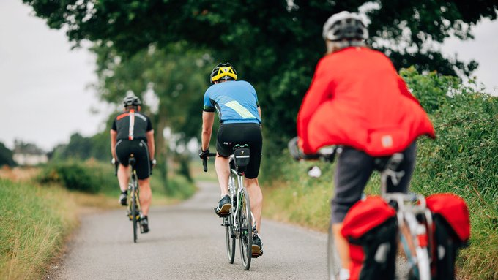
SNDC would like your feedback for a new sports and physical activity strategy for Greater Norwich. Everyone over the age of 16 will be entered into a prize draw to win one of three Amazon vouchers worth £100, £75 and £50. Complete the survey today at http://ow.ly/fKNN50GE0Ne

