Councillor Vic Thomson’s report for May/June 2022
The Jubilee is cause for national celebration and Norfolk is playing its part.
The efforts in Norfolk are being led by the Lord Lieutenant, ably supported by her Deputy Lieutenants who are leading different strands of work.
The initiatives planned in Norfolk are something we can be proud of, and I would like to commend the Lord Lieutenant, the Deputy Lieutenant and everyone who has contributed. Norfolk County Council are actively involved in supporting this work, as well as our own events and activities at council services.
Major Jubilee Initiatives in Norfolk
There are three major initiatives being promoted by Lord Lieutenancy as part of the Jubilee celebrations in Norfolk. They are:
A Royal Salute
A special musical celebration of Her Majesty’s 70 years on the throne, devised by David Stowell and Peter Wilson, featuring the talents of over 1,600 of Norfolk’s schoolchildren, a chorus of 150 voices, the 60-strong Norfolk Music Hub Ensemble, Norca Sistema’s Samba band, the Norfolk African Choir, and including two specially commissioned original pieces of music.
There will be two performances of A Royal Salute at the The Royal Norfolk Showground on Wednesday June 29 and Thursday June 30 to coincide with the Royal Norfolk Show.
Further Information can be found here.
The Platinum Jubilee Norfolk Challenge Awards
This award will be given to those young people (and adults) who are making a significant contribution to the Norfolk community as part of the Platinum Jubilee celebrations and beyond. They have been developed in tribute to the late Duke of Edinburgh, whose own Award scheme has been so influential on the lives of generations of young people.
Participants will be asked to take on the challenge in 4 areas: ‘Being active in Norfolk’; ‘Protecting our environment’; ‘Learning legacy’; and ‘Celebrating the Jubilee’
Further Information can be found here.
Jubilee Trails
The aim is to create trails which were within reach from all over Norfolk, where possible, with improved accessibility for all and linked into the existing rights of way network. The trails are a combination of existing, and in places, improved rights of way, together with new trails which open up parts of Norfolk which previously had no public access. The trails encompass all aspects of wonderful Norfolk from coastal scenery, woodlands, arable, historic, urban and more.
The 4 trails will go from: Heacham to King's Lynn; Gressenhall to Dereham; Great Yarmouth to Lowestoft; and Gayton to Castle Acre.
Further information can be found here.
Supporting National Schemes
Beyond the local events, Norfolk is supporting national initiatives in celebration of the Jubilee. This includes:
The Queen’s Canopy
This is an initiative to celebrate The Queen’s Platinum Jubilee by encouraging people to plant and protect trees as a legacy to Her Majesty’s Service to the Nation.
A tree was planted at County Hall to mark the start of the initiative in Norfolk, further details here.
Queen's Jubilee Beacons
As part of this year’s Platinum Jubilee celebrations, individuals and organisations are being invited to lead the nation’s tribute to Her Majesty the Queen by lighting beacons at 9.45pm on 2 June.
Norfolk has one of, if not the, highest number of beacons being lit among counties in England.
Events at Norfolk County Council Services
As well as supporting the Norfolk-wide Jubilee celebrations, services across the county council are putting on their own events. This is not an exhaustive list but give a picture of the activities being planned.
Library and Information Service- Norfolk's Great Big Jubilee Read
Between Tuesday 3 May and Friday 10 June, Norfolk's Libraries are showcasing 'The Big Jubilee Read', a national celebration of great books from across the Commonwealth, to coincide with the Platinum Jubilee. It features 70 titles - ten from each decade of the Queen's reign.
Find out more about the promotion and view the feature titles

Individual libraries are offering a number of different Jubilee themed events, including

- Jubilee Big Read
- Jubilee Just a Cuppa
- Jubilee Storytime
- Jubilee Crafts

For a list of what’s happening in every library go to their website.

Adult Learning – Jubilee Celebration event
Norfolk County Council’s adult learning service are holding an event on Thursday 26th May at Wensum Lodge from 10am – 3pm to celebrate the Queen’s Platinum Jubilee.
Tutors from Creative, Culture and Leisure, Family Learning and Community will be attending to help people with activities such as: Creating a ‘commemorative Royal plate’ with images of our Queen; Creating collaborative bunting; Making decorative willow crowns; tips and tricks for Jubilee food.

Norfolk Museum Service – Display at Jarrold Department Store
Forming part of their “Keeping it Regal” trail through the city, the museum service are putting on a special celebration for the extended Queen’s Jubilee weekend of 2-5 June which will see a stunning royalty-themed window display in Jarrold department store, brought to Norwich in partnership with the British Museum. The display will feature British Museum objects and a programme of performance art.

Dedicated Website and Events pages
A dedicate webpage has been develop on behalf of the Lord Lieutenant to capture all of the information about Jubilee events in Norfolk.
This can be found at https://www.platinumjubileenorfolk.org/
This includes an events listing page that anyone can submit their jubilee events to.
Norfolk residents can also submit their tributes to the Queen which will be collected and presents to Her Majesty at the end of 2022.
Have you heard of the Norfolk Residents' Panel As we look to the future we want local residents to help us decide which direction to take and how we can all get Norfolk thriving. This is your chance to sign up and be involved! Sign up now: https://orlo.uk/SignUp_kZA67
Hardship fund
Norfolk County Council is today unveiling a £7.7m package of hardship support offering increased flexibility and choice in the way a broader range of households can access help.
The council is topping up £6.7m of Government funding from the Household Support Fund with a further £1m to create a new Norfolk Cost of Living Support Scheme which will help people who are struggling to pay for food, energy and water bills, and other essentials.
Cllr Andrew Proctor, Leader of Norfolk County Council, said: “The main challenge facing us all is the spiralling cost of living which is hitting a wide number of households hard. That’s why we’ve created a new scheme that is flexible and can reach a broader range of people than previous hardship schemes. This includes families in need, older people and other vulnerable households.
“Previously the focus of our support has been on helping those facing hardship as the economy recovers from the pandemic and providing a bridge between the end of furlough and the Universal Credit top-up. Our new Cost of Living Support Scheme builds on what has worked previously but is able to reach a much wider group of residents, in-line with Government guidance.
“Some of the money is directed to the Norfolk Assistance Scheme, which is a robust and proven welfare offering to help households meet their immediate and longer-term needs, as well as channelling funding through our partners in the voluntary sector and other local authorities to expand capacity for wider support needs.”
“We’ve also topped up the funding from government with an extra £1m, so that our fund can reach even more households facing hardship.”
To ensure part of the support the council is offering is sustainable for the longer term, in addition to the £7.7 million Cost of Living Support Scheme, the council is investing a further £225,000 of capital into its partnership with the Norfolk Community Foundation Nourishing Norfolk food hub offer, bringing the total investment over the last year to £500,000.
Claire Cullens, Chief Executive of Norfolk Community Foundation, said: “We are delighted to continue our work with Norfolk County Council to support those communities who are struggling and face real economic challenges.
“This funding injection is enabling us to deliver a coordinated programme of help in partnership with our local and vital Norfolk charities. The additional funding support to our Nourishing Norfolk programme will enable us to accelerate the development of affordable food hubs across Norfolk to ensure that no one in Norfolk goes hungry.”
The £7.7 million Norfolk Cost of Living Support Scheme, which will run until October, will be administered as follows:
- £3.6m to support families with seven monthly cost of living vouchers for children eligible for means-tested free school meals. The payments will be £15 per month, per child, with an enhanced payment of £30 for August, to coincide with the school holidays. The total value will be £120 per child, over the course of the scheme. The vouchers will be paid from April (backdated) up to and including October. This approach gives families flexibility and choice by allowing them to budget monthly and offset vouchers against other financial pressures on their household bills and activities. It also means families will have payments during and outside school holidays with the option of saving them to use only in the school holidays if they prefer
- £1m allocated to the council’s Norfolk Assistance Scheme (NAS) to support families in hardship, where there isn’t eligibility for free school meals. This support is available to families with very young children, young carers, and families caring for children with disabilities, many of whom may be facing significantly higher energy bills
- £2.2m, a third of the Government funding, to support those aged 65 or over by providing cash and voucher awards through the voluntary sector and other partners, including a specific collaboration with Anglian Water, as well as support through NAS. The work with Anglian Water will support customers aged 65 or over who are on Anglian Water’s social tariffs, because they are in financial difficulty, providing a package of support to reduce and prevent debt. £700,000 of this funding will be distributed to district, borough and city councils to support vulnerable communities
- £840,000 to support others in need, including funding for district, borough and city councils to meet immediate housing related concerns. This part of the scheme will also mean that voluntary sector agencies can refer those they are working with to the council for support
We would always encourage residents who find themselves in hardship to contact us on 0344 800 8020, so we can offer support either directly or through our partners.
Rooting for Nature – Composting campaign launches with a chance to win a free compost bin
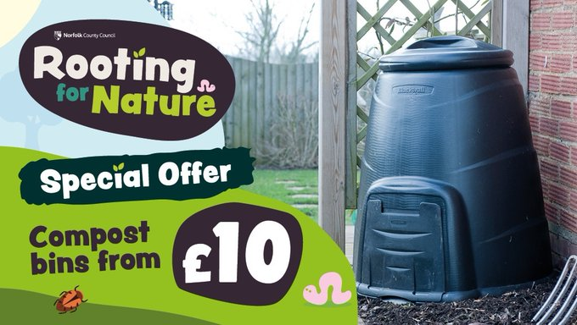
Rooting for Nature, Norfolk County Council’s popular composting campaign is back to encourage more people to switch to composting at home and help reduce and recycle more of their waste.To encourage more residents to get composting, Norfolk County Council has a special offer on compost and bokashi bins. Residents can buy a bin from as little as £10 (220 litre black bin, standard price £22) and there’s also a buy one, get one half price offer.
**A launch event will be held at Thetford Reuse Shop on Thursday 12 May. Norfolk’s Master Composters will be on site to advise and answer questions on composting and to demonstrate how it’s done. Plus, there’s a chance to see a compost bin beautifully transformed by Norfolk artist Jackie Piermont. The specially designed bin will then go on tour to Norfolk events throughout the spring.**
To mark the campaign launch, the council is also running a big bin giveaway with 50 free compost bins plus free home delivery up for grabs. To register to win a bin, fill in a quick online form at www.norfolkrecycles.com/win-a-compost-bin. The closing date is 26 May 2022.
Find more information about composting and how to buy a compost bin at Norfolk Recycles www.norfolkrecycles.com/home-compost
So what’s a Bokashi bin?

A Bokashi bin is great for taking home composting to a new level! It’s a nifty container that lets you compost all your food waste including cooked food, meat, fish, dairy and all sorts of other organic material.
We’ve teamed up with GetComposting to offer you a twin pack for just £15. To see this and our other compost bin offers visit our website https://orlo.uk/GetOffer_wj7DE


Have you ever thought about volunteering as a panel member for School Appeals? We're looking for volunteers now If you are interested, please contact Perry Richens-Pyatt via email p.richens-pyatt2@norfolk.gov.uk for an application form.

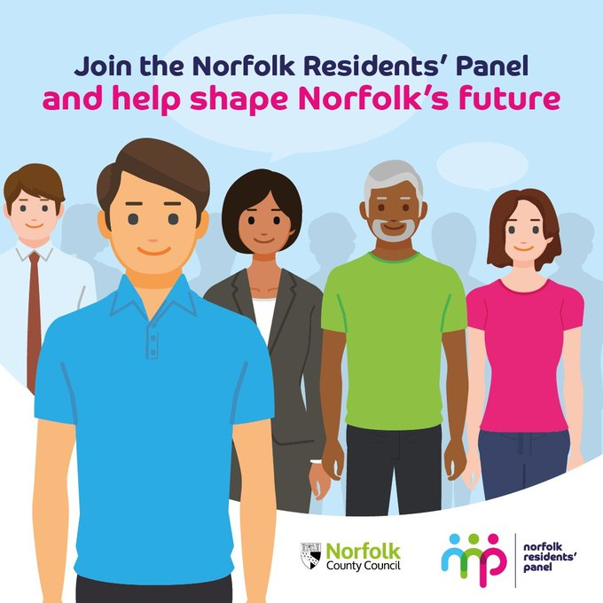
Could you be part of the Norfolk Residents' Panel We want local residents to help us decide which direction to take as we look to the future and how we can all get Norfolk thriving. This is your chance to sign up and be involved! Sign up now: https://orlo.uk/vr4YO

River bank stabilisation: waiting for date
FTTP voucher scheme: paused during national procurement
CAF funding
The Community Action Fund (CAF) is in place to support groups who require a larger amount of funding than the Members Ward Fund can support. District Councillors are responsible for receiving, considering and proposing applications for funding between £500 and £15,000.
The aim of this funding is to: • build capacity within communities so that groups are enabled to be self-sustaining without ongoing practical and financial support from the Council, • stimulate local economic growth, and • facilitate creative partnership approaches to helping people in need at the earliest opportunity.
SNDC One Team
Both councils have agreed to move their officers into one building at the Broadland Business Park and close existing offices.

