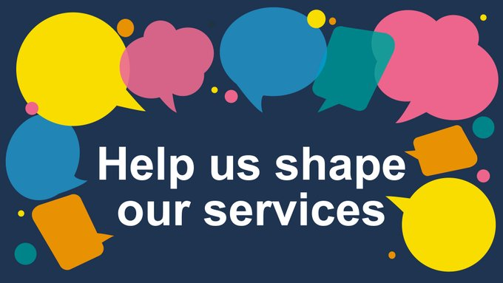
We want you to have your say on the services we provide, and help shape them for the future. Join our Customer Panel here - http://smartsurvey.co.uk/s/CustomerPanel-fb/

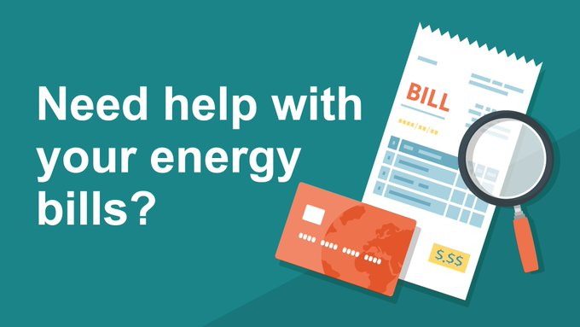

The Energy Rebate Scheme is still offering certain households additional funding on top of the £150 awarded via Council Tax in the spring. Apply now - http://southnorfolkandbroadland.gov.uk/EnergyRebateScheme
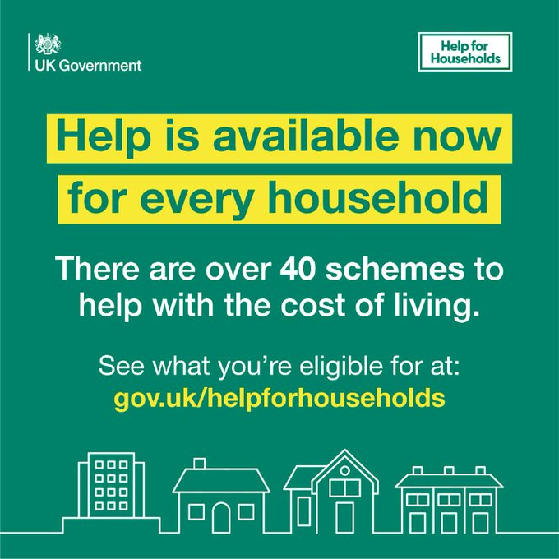
Families across the country are already receiving help with their bills. Join them and check what you’re entitled to.

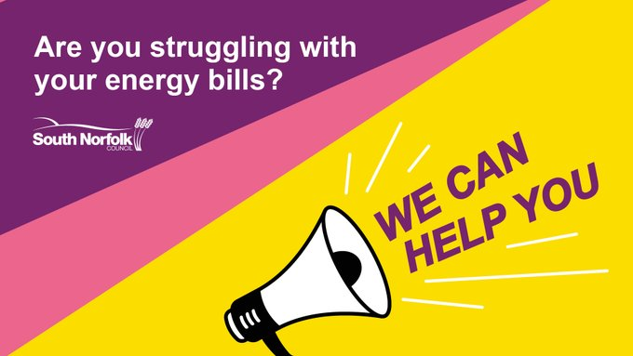
Need help with your energy bills? Our energy rebate scheme is open until the end of November. Find out if you can receive support at: http://ow.ly/WHXT50Lo2Ww #SupportingCommunities

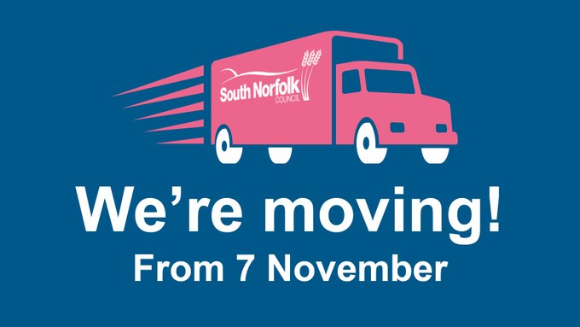
Our offices in Long Stratton will be closed from 7 November, and we will be temporarily based at Thorpe St Andrew, as we get ready for the move to our new home at the Horizon Centre at Broadland Business Park. Find out how you can access our services: https://southnorfolkandbroadland.gov.uk

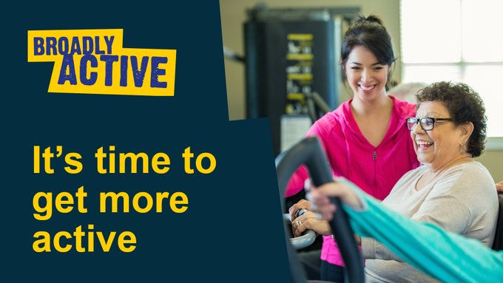
If you have a health issue such as anxiety, diabetes, arthritis or chronic pain and want to become more active – then our exercise referral scheme, Broadly Active, could be for you. Find out more: http://ow.ly/Qq5g50K07nW #SupportingIndividuals

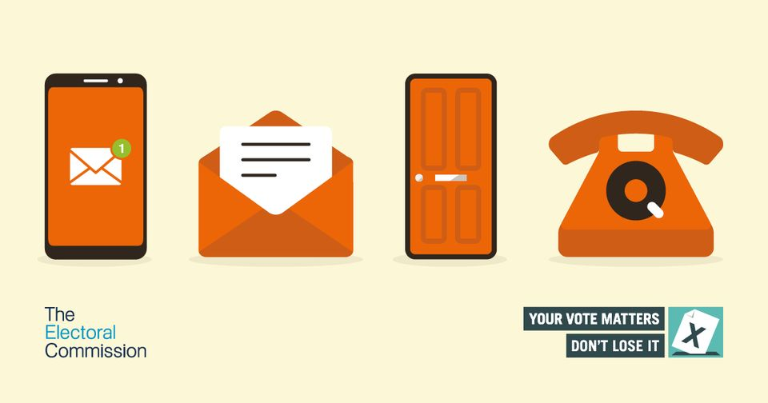
Had a letter from us asking about your details on the electoral register? We're checking the register is up to date.
Follow the instructions and get back to us as soon as you can, so you're ready to vote in upcoming elections

Bin collection
There are times when we change our bin collection during holidays. You can always check your bin collection days at: http://ow.ly/zEmX50KsaLm

My Area - Find Address - My Area (southnorfolkandbroadland.gov.uk)
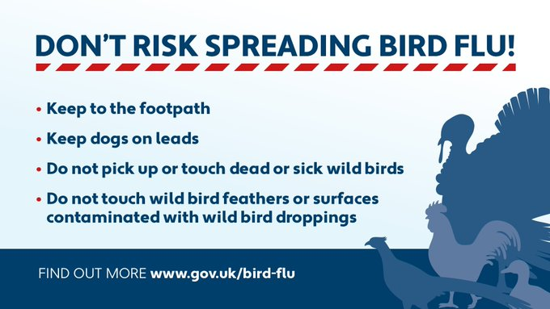

Adult learning
A Norwich man has succeeded in his dream of becoming a paramedic and a Thetford woman is taking her first step towards a teaching career, all thanks to GCSE results achieved with Norfolk’s award-winning Adult Learning service.
The service has seen excellent results across both English and maths GCSEs this year. Of 91 adult GCSE students sitting formal exams for the first time since 2019, 73% achieved Grade 4 or above in maths and 78% achieved Grade 4 or above in English.
Norfolk Adult Learning, which is rated Good by Ofsted, offers free English and maths GCSE courses to adults aged 19 or over. The service offers a range of vocational qualifications and apprenticeships with subsidised courses including accountancy, access to higher education, health and social care, English and maths qualifications, including GCSE, childcare and teaching qualifications, and family learning, as well as community-based and leisure courses designed for people to try a new hobby, learn a new skill or get back into learning.
All courses are taught by professionally qualified, passionate tutors who are experts in their field. In addition to a dedicated apprenticeships team there is an experienced team of advisors offering ongoing specialist learning support, and information, advice and guidance to help people beginning a path to a new career or life goal.
For more information about free GCSE English and maths visit our GSCE courses for adults webpage.
For more information about Adult Learning visit our Adult learning webpages.

Want to brush up on your Microsoft Office skills? We have training courses available in Microsoft Word, Excel and PowerPoint for beginners to confident users, delivered at Carrowbreck House Training Centre in Hellesdon. Find out more: http://ow.ly/suH750K26kU

Nutrient Neutrality
We are still working to meet the requirements of NN to enable new houses to be built.
It is a difficult process, and I will keep you apprised as and when we make progress.
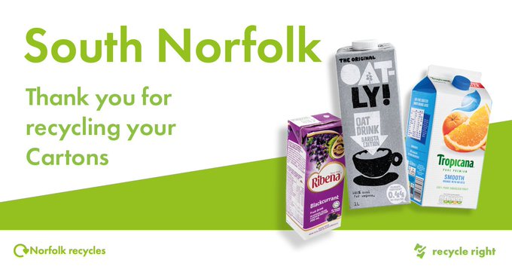
Recycle your cartons. This might be Tetra Pak for milk, cartons of juice, smoothies or cartons of soups. Rinse them out and once they’ve dried place them in the recycling bin. Cartons #RecycleRight #RecycleYourCartons

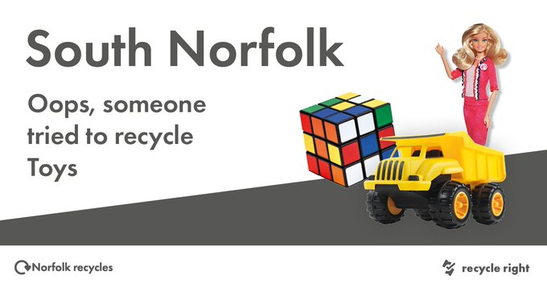
Hard plastics, like toys or clothes hangers can’t be recycled. If they are still in good condition, donate them to a charity shop or offer them on Freegle. #RecycleRight #Freegle #Reuse

New Office
From early November we will move to Broadland gate
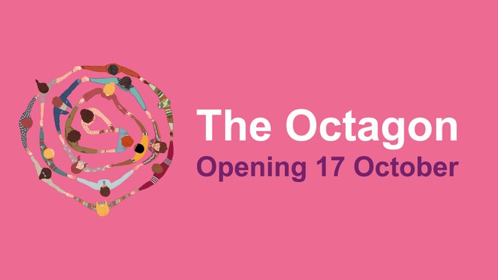
On Monday 17 October, we are opening a new community office at The Octagon in Diss. This will provide a space for pre-booked meetings and support to access our wider services. Find out more: http://ow.ly/ax5t50L0EV1

Energy Support Payments We have now written to eligible households over 65 years old who can benefit from the discretionary energy payment scheme. We have identified these households through our new Low Income Family Tracker database. These households will receive a payment of £300 directly into their account, which is in addition to the current £150 Energy Rebate. This payment is a grant and will have no effect on any welfare benefits they may receive or any income tax payments. All these payments will happen in October 2022. For further information, please contact Lindsay Sayer lindsay.sayer@southnorfolkandbroadland.gov.uk

Warm Spaces Grant The Council is pleased to announce a new grant offering up to £600 to support the provision of ‘Warm Spaces’ in the district this winter. The grant is available to Town and Parish Councils, community groups, CIOs, CICs and faith groups, etc. in order to provide a free space that residents can visit to keep warm during the winter and potentially engage in activities or access wider support services. Applicants will be supported by the Communities Team to develop their plan, engage with audiences and apply for alternative funding sources if required. The grant criteria and application form is now live on the Council’s website. For more information, contact Dan Goodwin on 01603 430563 or dan.goodwin@southnorfolkandbroadland.gov.uk
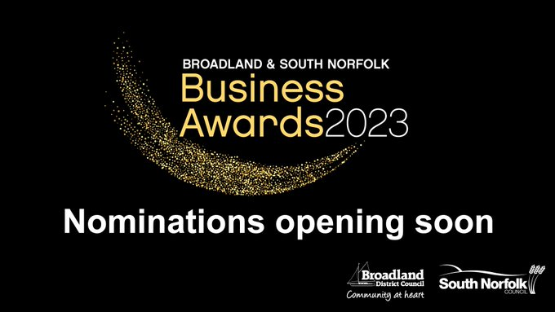
Our Business Awards are back with nominations opening soon. We'll be celebrating the achievement, innovation & diversity shown by businesses across Broadland and South Norfolk & we're introducing a brand new Pub of the Year category for public nomination! http://ow.ly/eJj250L8cZU

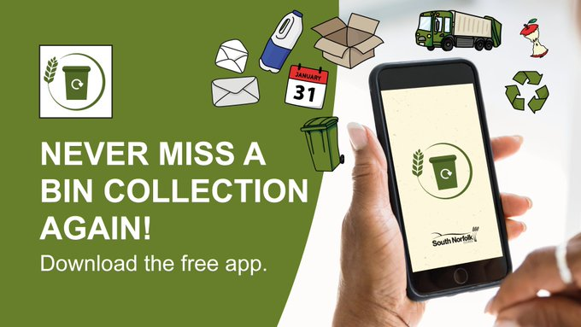
Download the app to find out when your bins go out and receive notifications about your collection and any potential disruptions. You can also find out about what goes in what bin! Find out more and download today at: http://ow.ly/5a9z50LfbWb

