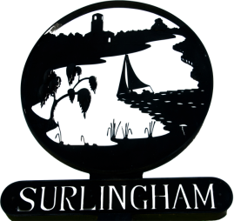
SURLINGHAM PARISH COUNCIL
The Parish Council meetings are open to the public to observe, they are not public meetings. There is the opportunity for the public to ask questions at every meeting.
Members
You are summoned to attend the meeting of Surlingham Parish Council to be held on Tuesday 14 March 2023 at the Parish Hall at 7.30pm in line with standing orders the meeting will close no later than 9:30.
Charlotte Rust, Parish Clerk
Tel: 07960 887791
Agenda.

- Welcome by the Chairman
- Apologies and approval of absences
- Declarations of Interest
- To approve as accurate the minutes of the meeting on 21 February 2023
- Matters arising from those minutes.
- Progress report for information on items not on the agenda: Councillors/Clerk
- To receive reports from the County and District Councillor
- Public Question Time
- Chair to sign Clerk Contract
- Bank Mandate Changes
- To discuss new payroll services
- The Big South Norfolk Litter Pick 2023
- Cycling Petition
- Planning Permission:
  - 2022/2301 – Engineering operations to raise ground levels within the site – Amended plan
- Correspondence –
  - New Road Safety Scheme
  - Village Hall sign
  - Highways Enquiry – ENQ900224605 PROW update
  - King’s Coronation Grant
  - Defibrillator – site check
- Hall – Maintenance
- Finance – Authorise Payments
- Date of next meeting 11 April 2023

